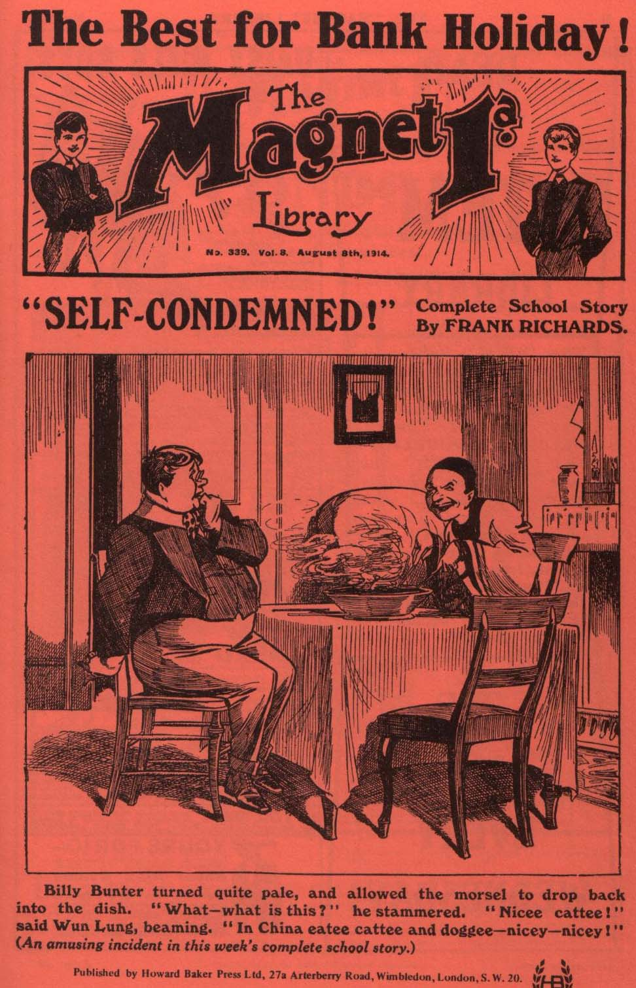
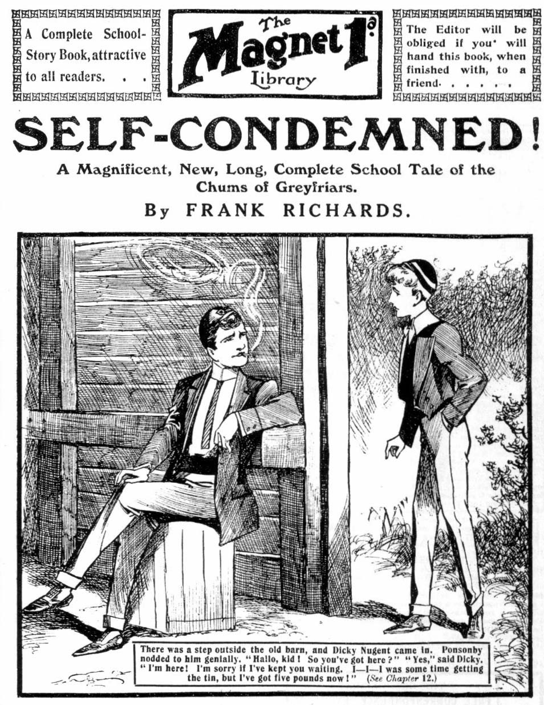
THE FIRST CHAPTER.
A Debt of Honour!
“DICKY!”
Harry Wharton, the captain of the Remove at Greyfriars, uttered the exclamation sharply.
Wharton had just entered his study, No. 1 in the Remove passage. He had not expected to find anyone there, as he had left his study-mate, Frank Nugent, downstairs. But as he came in a boy who was standing at Nugent’s in the corner swung round, and faced him, with a startled flush on his face.
It was Nugent minor—Dicky Nugent of the Second Form.
Wharton looked at him sharply.
Nugent’s desk was open, and the contents disturbed, and it certainly looked as if Dicky Nugent had been going through his major’s belongings. And the guilty flush deepened in the fag’s face as Wharton scrutinised him.
“What are you doing here, Dicky?”
The fag seemed at a loss for words for a moment. He had evidently not expected to be discovered by the captain of the Remove. He closed the desk, his face crimson.
“I—I’m waiting for Frank!”
“And going through his desk while you wait!” rapped out Wharton.
Nugent minor looked sullen.
“Why shouldn’t I go to my brother’s desk if I want to?” he exclaimed. “I suppose you don’t think I’m stealing anything ?”
“Of course I don’t, Dicky. Don’t be an ass! But you shouldn’t do such things, all the same.”
“Oh, rot!”
That reply to the captain of the Remove, from a fag of the Second Form would have earned a cuff. But Frank Nugent’s minor was a privileged person. Wharton frowned, and pointed to the door.
“Travel!” he said briefly.
Nugent minor did not move.
“I want to see my major.” he said doggedly.
“He’s downstairs.’’
“I want to see him here. I’ll wait till he comes in.”
“Wharton regarded the fag curiously. The flush had died out of his face now, leaving it unusually pale. There was a line in the smooth, boyish brow, a troubled look in the handsome blue eyes. Nugent minor was an extremely good looking lad, and Wharton knew that he had been petted and spoiled at home, and he had given his major a great deal of trouble when he first came to Greyfriars. Since then, however, most of the nonsense had been “knocked out” of Dicky by rough contact with the fags of the Second. he was no longer the spoiled darling he had been, but the cheekiest fag in the Second Form. But just now ho looked very like his old self. His expression was sullen and dogged, and there were signs of trouble in his face that Wharton could not quite understand.
“Anything the matter, Dicky?” Harry asked good-naturedly. “If there is——”
“Yes, there is!” muttered Nugent minor.
“What is it?”
“Nothing to do with you!” said the fag sullenly. “I want to speak to Frank.”
Wharton coloured a little. He was greatly inclined to take the sullen fag by the scruff of the neck and pitch him out of the study. But he remembered in time that he was the brother of his best pal. Wharton kept his temper. There came an interruption at that moment.
“Coming, Harry?”
It was Frank Nugent’s voice from the stairs.
“Yes, I’m coming.”
Wharton picked up his bat, for which he had come to the study, and walked out, without another word or look to the fag. He was frowning as he joined his chum.
“Jolly long time getting that bat.” said Nugent. “Hallo! What are you scowling about?”
Wharton laughed awkwardly.
“I wasn’t aware that I was scowling.” he said, his brow clearing.
“Frowning, then, if you like that better.” grinned Nugent. “ What’s the row?”
“Your minor’s in the study and he wants to speak to you.
“Let him wait, then! We’re going down to the cricket.”
“Better go, Franky. He looks as if he’s in some trouble
or other!”
Frank Nugent gave a comical groan.
“Thank your lucky stars you haven’t a minor.” he said.
“I’d swap mine for your white rabbit, any day. Why can’t he come down?”
“Better go, anyway.”
“Oh, all right! I’ll follow you!”
Wharton nodded, and joined Bob Cherry and Johnny Bull and Hurree Jamset Ram Singh, who were waiting for him in the doorway of the School house. Frank Nugent ascended the stairs to the Remove passage and went into his study.
“Well, Dicky! Wharton says you want to speak to me.” he said. “What is it?” Then Nugent looked more closely at his minor’s face, and started a little. The fag seemed on the verge of tears. “Dash it all, kid, what’s the matter? Loder been bullying you again?”
Dicky shook his head.
“Is it Bolsover major? If so—”
“It’s not that!”
“Then what is it?” asked Nugent. “You look as if you’d been hunting for trouble, and finding it.”
“Shut the door.” said Nugent minor nervously.
“What for?”
“I—I want to speak to you.”
“Can’t you speak with the door open?” demanded Nugent, in wonder. He threw the door shut and it slammed. “Now, what is it?”
“I—I—I stammered Dicky . “ I—I’m in trouble, Frank.”
“Yes, you look like it.” groaned Nugent. “You generally are in trouble. Nobody been ragging you?”
“No, no!”
“Is it your Form-master?”
“Then what the deuce is it? Over run your account at the tuckshop?”
“Worse than that!”
“Well, get it out.” said Nugent major resignedly. “They planted you on me to look after, and I suppose it’s up to me to do it. If you’re stony broke, I’ve got a bob you can have!”
“A bob’s no good!”
“Isn’t it?” said Nugent warmly. “It’s the last one I’ve got, anyway.”
“I—I’m in trouble. I want you to help me out, Frank.”
“Well, ain’t I here, ready to help you?” demanded Nugent. “What do you want? If it’s money, you can have my last bob. I can do no more than that.”
“It’s money.” said Dicky.
“You careless young ass! I suppose you’ve been buying something you can’t pay for, is that it? Well, it might be
worse. I can borrow some money of the chaps, I suppose, and make it up out of my next allowance. You’ll bring me to bankruptcy if you keep on like this. How much is it?”
“Five pounds.”
Nugent jumped.
“Do you mean five shillings?”
“I mean five pounds.”
“Oh, don’t be funny!” snapped Nugent. “You know jolly well I’ve not got five pounds. Why don’t you say five hundred?”
Dicky Nugent did not reply. He sank into a chair, and covered his face with his hands. Nugent’s expression softened again.
“For goodness’ sake don’t blub!” he exclaimed, in alarm. “ Chuck that, Dicky! Look here, what do you mean? What can you possibly want five pounds for? You can’t possibly owe anybody so much money as that—it’s rot!”
“I do!”
“You owe five pounds?” exclaimed Nugent, in angry astonishment. Then it can’t be the tuckshop. They wouldn’t let you run more than five bob. You haven’t had the cheek to buy a new bike, I suppose?”
“I haven’t been buying anything.”
“Well, if you haven’t bought anything, you can’t owe the money for it.” said Nugent. “ So just tell me what you want five quid for, young shaver. Not that there’s the slightest chance of your getting it.”
Dicky raised a pale and tear-stained face from his hands.
“I must have it, Frank.” he said hoarsely. “I tell you, I’ve got to have it. It—it’s a debt of honour.”
Frank Nugent looked steadily at his young brother. He seemed unable to speak for a moment. The statement that a fag in the Second Form owed a debt of “honour” to the tune of five pounds took his breath away, as well it might.
“You young rascal!” exclaimed Nugent, at last, his anger breaking out. “A debt of honour! Don’t talk such silly rot to me! The long and the short of it is, then, that you’ve been gambling.
“I got among some fellows.” faltered Nugent minor miserably. It— it was last half holiday. It was all right. They were decent chaps. But —but I lost, and--and I’ve got to square up, Frank. I can’t refuse to pay, can I? I lost the money, and they accepted my I O U. I can’t be such a cad as to refuse to pay. It would be swindling. You don’t want me to be a swindler?”
“You young fool!”
“It might happen to anybody.” said the fag defensively.
“Look here, it isn’t so very much, after all. I can raise the
money in time. Uncle George gives me five quid every
birthday. I can get some money from home. The mater
will send me some if I ask her, but—but of course I can t
tell her what it’s for. If you lend me the money I can
square up—in time.”
“I haven’t the money, and you know it. And if I had, I
wouldn’t hand you a single tanner to pay a gang of
swindlers!”
Dicky flushed angrily.
“They’re not swindlers. They’re all decent chaps enough.
They pay when they lose. I’ve played with them before, if
you must know all about it. I—I won a quid once. I’ve
had their money, and spent it. How can I refuse to pay when I lose ? It wouldn’t be decent. It wouldn’t be honest. You don’t want to make a swindler of me, do you?”
Nugent breathed hard.
“Who were the fellows?” he asked.
“ I’m not going to tell you!” said Dicky sullenly. “You’d
only want to make a row with them.”
“Exactly!” said Nugent, between his teeth. “I want to find the rotters who’ve been making you play, Dicky, and give them a hiding all round. Are they Greyfriars fellows?”
“Find out!”
“I will find out!” said Nugent, clenching his hands.
“As for you, you young rascal, you won’t get a penny out of me for anything of the kind. I suppose its no go telling you that it’s disgraceful to gamble—you know that as well as I do.”
“Loder does it.” said Dicky sullenly. “Everybody knows—excepting the masters—that Loder and Walker play cards for money.”
“Yes, and they’re a pair of cads. Don’t talk to me You know it’s wrong, and you know it’s dirty blackguardism!” said Nugent fiercely. “I wonder you’ve got the cheek to come here and tell me you’ve done it. Any other fellow would give you the licking of your life.”
“I’ve only told you because I want you to help me.” said Dicky, his lip quivering. “I’ve got to pay somehow. It’s a debt of honour.”
“Debt of rats!” snorted Nugent. “Now, look here—”
“You can lend me the money, Frank, if you like. I know you’ve got it. It isn’t as if I wouldn’t square. You shall have it all—”
“I tell you I haven’t it.”
“You have! I’ve seen it in your desk!”
Nugent started. “You cheeky young sweep! Have you been meddling with my desk?”
“You’ve got six pounds there—”
“That’s not my money! It’s the funds of the cricket club!” said Nugent. “I’m secretary and treasurer—you know that.”
“It’s all the same; I can let you have it back before it’s wanted.”
“So you want me to embezzle the funds of the cricket club for you to hand the money to a gang of sharpers!” shouted Nugent .
“They’re not sharpers—Ponsonby and—”
“Ponsonby! Then it’s the Highcliffe fellows you’ve been playing with!” exclaimed Nugent.
Dicky bit his lip. He had not meant to allow that piece of information to escape him. But it was out now. Frank Nugent’s face was pink with rage. He knew the manners and customs of Ponsonby & Co., the “blades” of Highcliffe school. That they should dare to draw the foolish and reckless fag into their rascality excited Nugent’s temper to boiling point.
“Never mind who they are.” said Dicky hastily. “I’ve got to pay, anyway, and if you won’t help me I’ve got to get the money somewhere else.”
Nugent strode across the study and grasped his shrinking minor by the shoulder and shook him savagely.
“Look here,” he said, his voice trembling with rage— “Look here, Dicky! I forbid you to pay those rascals a single penny! Do you hear? If I find out that you’ve paid them anything, I’ll thrash you—thrash you till you can’t crawl! Do you understand that? ”
Dicky Nugent’s face set sullenly, but he did not reply. Nugent looked as if he would carry out his threat there and then if the fag added another word.
“As for your precious friends, I’ll teach them to get you into gambling!” went on Nugent, gritting his teeth. “I’ll see Ponsonby—”
“You won’t! You sha’n’t——you sha’n’t make me look an
ass like that! Let my affairs alone and mind your own business!” cried the fag shrilly. “If you won’t help me, mind your own business!”
Nugent made no answer. He gave the fag another angry shake, and then released him, and strode to the door, his face white and set.
Dicky sprang after him.
“Frank, where are you going?”
“I’m going to Highcliffe!” said Nugent, without turning his head.
“You can’t ! You sha’n’t!” Dicky caught his brother’s arm. “Frank ! Stop, I tell you! You sha’n’t meddle in my business! I tell you—”
Nugent turned upon him savagely. With a ringing cuff, he sent the fag staggering back into the study. Then he hurried downstairs, with gleaming eyes.
THE SECOND CHAPTER.
Something Like a Licking!
“HALLO, hallo, hallo! What’s the matter with Franky?”
Harry Wharton & Co. were on the cricket ground.
Some of the Remove fellows were at practice, but the Co. were waiting for Frank. They stared at him in amazement as he came up. His face was white, his lips set, his eyes glittering. Never had the chums of the Remove seen Nugent look like that before.
“What on earth’s happened?” cxclaimd Johnny Bull, ín alarm.
“Dicky—” began Wharton.
“I want you fellows to come with me if you will.” said Nugent hoarsely. “I’m going over to Highcliffe to see Ponsonby.”
“Highcliffe!”
“ Ponsonby!”
“But what has happened, my esteemed chum.” nurmured Hurree Jamset Ram Singh, “and what abcut the cricket?”
“Hang the cricket!”
“Ahem! But———”
“I’ve got an account to settle with Ponsonby.” said Nugent, his grasp tightening almost convulsively upon a riding-crop he held in his hand. The juniors glanced at it.
“Where did you get that?” asked Bob.
“It’s Coker’s. I’ve borrowed it.”
“What for?”
“For Ponsonby.”
“Phew!”
The chums of the Remove exchanged curious glances. They had never seen Nugent so disturbed before, and they knew that something very unusual must have happened to throw the good natured and genial junior into such a fury. It was probable enough that Ponsonby of the Fourth Form at
Highcliffe deserved a horse whipping——probably he deserved a good many. But the idea of going over to Highcliffe to horsewhip one of the fellows was, as Bob Cherry remarked, a little “thick.” There was no love lost between Ponsonby & Co. and the chums of the Remove at Greyfriars, and Harry Wharton & Co. had sometimes raided their old rivals, even in their own quarters. But—”
“Well, are you coming?” said Nugent impatiently. “If
you’re not, I’ll go alone. I thought you might come and see fair play.”
“Not likely to get much fair play among those fellows, Frank.” said Johnny Bull. “If you want to tackle Ponsonby, it would be better to get at him outside Highcliffe.”
“Can’t wait for that.”
“And you know last time we raided them Mobbs, their Form-master, came over and complained to the Head, and there was a dickens of a row. They don’t play the game.”
“I don’t care!”
“Well, I do, a little bit.” said Johnny Bull rather tartly. “I suppose you tell us what the trouble is about, for a start?”
Frank Nugent did not reply. He turned and strode away towards the distant school gates. The Co. started after hin at once.
“Hold on a minute, Frank!” exclaimed Wharton. “Keep your wool on! Surely you can tell us what we’re to raid them for?”
“It’s not a raid, and it isn’t ‘them’ —it’s Ponsonby. And I’m going to horsewhip him.” said Nugent, “ and I’m not going to tell you anything. If you can’t take my word for it that I’ve a good reason, you needn’t come.”
He spoke without slackening his pace. But his chums were hurrying along with him now. They did not intend to let him go alone.
They were frowning a little now. Nugent’s reply was not exactly polite, and the point of view he took was decidedly unreasonable. A raid on Highcliffe might lead to severe punishment, and the juniors naturally wanted to know what they were to raid Ponsonby for. But Frank Nugent had a natural disinclination to explain the disgraceful scrape into which his minor had fallen. The Famous Five had always been down on such things, and they had long been extremely rough on Vernon-Smith of the Remove for doing precisely what Nugent minor had done. Nugent did not wish to get Dicky’s rascally conduct spoken of at large, and he objected to even his chums knowing about it. But the Co., who didn’t know all that, of course, were surprised and somewhat exasperated.
“Look here!” exclaimed Wharton, as they passed out of the School gate. “I think you ought to tell us what the trouble is, Franky.”
“There’s no need.”
“Has Ponsonby done anythng to you?”
“Yes!”
“What has he done?”
“Acted like a rotten cad!”
“But in what way!”
“I’m not going to tell you!” said Nugent bluntly. “if you don’t want to back me up, you needn’t come with me, that’s all. I’ll go alone.”
“You jolly well won’t go alone; but I don’t see any reason to keep secrets from your own pals.” said Wharton crossly.
Nugent made no reply to that. He strode away down the lane at a rapid pace with a fixed brow. The juniors walked with him in silence. They were annoyed and disturbed, and they anticipated trouble; but they could not let their chum walk into a hornet’s nest by himself. Ponsonby & Co., of Highcliffe, had no idea of fair play. They would certainly pile on Nugent if he went alone—indeed, if the five went together, they ware pretty certain to find trouble. In grim and irritated silence the juniors made their way to Highcliffe, Nugent speaking no word, and the other fellows not feeling inclined to ask him any more questions.
Outside the gates of Highcliffe School, the thin and ungraceful figure of Mr. Mobbs, the master of the Fourth, could he seen. He was chatting with a junior, and in the junior they recognised Ponsonby, the fellow of whom they had come in search. They were glad to see him. Ponsonby was easier to deal with in the open than sought for in his own quarters within the school.
Mr. Mobbs’ manner towards Ponsonby was civil in the ext remc. Cecil Ponsonby trpated him with barely-disguised patronage. The dignity of a Form-master was an unknown quantity to Mr. Mobbs. He was a born tuft-hunter, and Ponsonby and most of his friends were rich and well connected, and Mr. Mobbs looked for future advantages by making himself agreeable to them. Old Dr. Voysey, the head of Highcliffe, was careless and remiss in his management, leaving most things in the hands of the under masters, and that, to a large extent, accounted for the “dry rot” from which the school was suffering. Ponsonby & Co. were accustomed to playing bridge and smoking in their studies, and haunting the billiard rooms in the vicinity; and if their conduct came to the knowledge of Mr. Mobbs, the Form-master discreetly closed his eyes to it
Nugent’s eyes glittered at the sight of Ponsonby, and he took a tighter grip upon the riding-whip.
“There he is!” he muttered.
“But Mobby is with him!” said Bob Cherry uneasily. “Dash it all, Frank, you can’t go for a chap under the nose of his Form-master.’’
“Can’t I?” said Nugent grinly. “I’ll show you whether I can or not.”
“ Look here, Frank—”
Nugent quickened his pace. Ponsonby glanced at him as he came up, and Mr. Mobbs looked at him with an eye of disapproval. Mr. Mobbs did not like the Greyfriars fellows— partly because Ponsonby did not like them, and partly on their own account. Ponsonby calmly screwed an eye-glass into his eye, and surveyed Nugent with a supercilious smile.
He did not appear to guess that Nugent was coming for him. After a supercilious glance, he ostentatiously turned his back on the Greyfriars junior, and went on talking to Mr. Mobbs.
“Certainly, Mobby.” he said. “I’ll ask my pater to have you down next vac. You can tell him what nice boys we are at school—what?”
Mr. Mobbs smiled and rubbed his hands.
“I should be delighted and honoured by an invitation from your respected father, Ponsonby. I—why——what—”
Nugent had come up.
His left hand was laid heavily upon Ponsonby’s shoulder, and the supercilious Highcliffe junior was swung violently round. Ponsonbv found himself staring into an angry face and two blazing eyes.
“You cad! Let go!” he shouted.
“I’ve just been speaking to my minor.” muttered Nugent, “You understand?”
“Let go my shoulder!”
“And I’ve come to thrash you.”
“You —you—!” Ponsonby clenched his fist and struck out, and Nugent received the blow full in the face. “Now let go!”
The blow was a heavy one, but Nugent did not seem to feel it. His grasp on Ponsonby’s shoulder did not slacken. He whirled up the whip, and struck Ponsonby across the face with it.
Slash!
Ponsonby uttered a yell of pain. Across his face lay the red mark where the whip had fallen.
“That’s for a start!” said Nugent grimly. “ Now I’m going to thrash you!”
“You—you—oh!”
Ponsonby swung round in Nugent’s grip, and the horsewhip rose and fell across his shoulders. Nugent had shifted his grip to Ponsonby’s collar, and his grip seemed like iron. Ponsonby struggled and kicked and yelled, but the Greyfriars junior held him fast, and the blows rained across his back.
Slash, slash, slash!
Harry Wharton & Co., who had been left behind by Nugent in his haste, came up breathless. Mr. Mobbs was gazing at the scene in horror and consternation, scarcely able to believe his eyes. That the junior should dare to lay hands like that on Cecil Ponsonby, whom Mr. Mobbs had been toadying to for a whole term, to secure that invitation from Ponsonby senior, was incredible—amazing—unparalleled. It really seemed like sacrilege to Mr. Mobbs. He stood rooted to the ground till Ponsonby’s wild yells roused him. Then he clutched his walking-stick and rushed to the rescue.
Mr. Mobb’s stick would have done Nugent some damage, but Bob Cherry put his foot in the way, and the Form-master stumbled over it, and measured his length on the ground.
And still Nugent was lashing away with the whip. He had no eyes for Mr. Mobbs; he did not even seem to see him. All his energies were devoted to thrashing Ponsonby; and certainly Ponsonby was getting the thrashing of his life. His struggles were of no avail; he hit and kicked, but hitting and kicking had no effect on Nugent. His grip on the young rascal’s collar did not relax for a moment, and the whip rose and fell with terrific speed and force.
“Ow, ow, ow! Help!” shrieked Ponsonby.
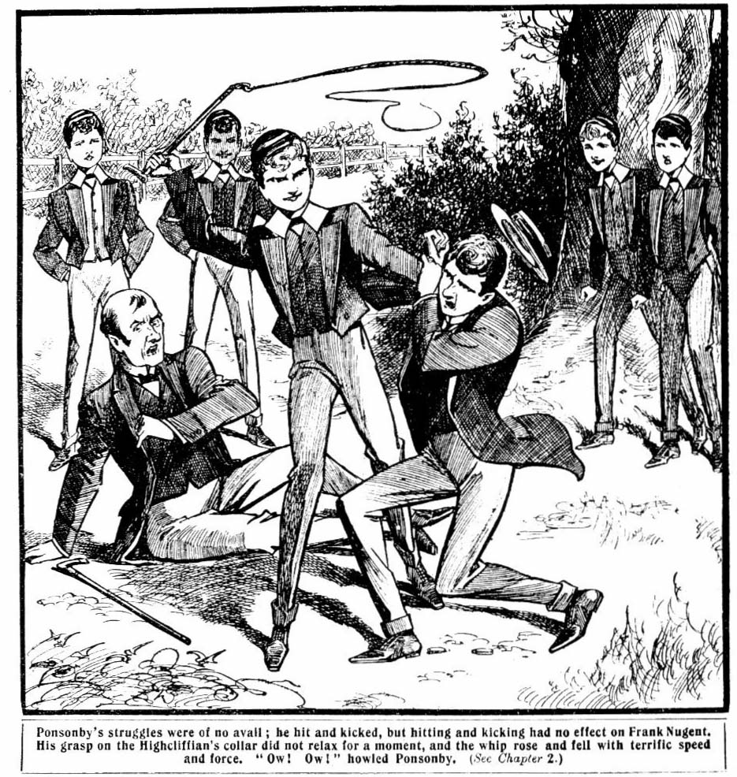
Mr. Mobbs sat up dazedly, gasping.
“Help! Police!” he yelled.
“Out of the school gates came crowding a dozen Highcliffe fellows—Ponsonby’s friends, Gadsby and Vavasour and Monson in the lead. Wharton grasped Nugent by the arm.
“That’s enough, Franky! Whatever he’s done, that’s enough! Leave off.”
“It’s not enough!”
“Let him go, I tell you!”
Wharton grasped the riding-whip from Nugent’s hand. Frank turned upon him savagely for a moment. But the Highcliffians were rushing upon them. Ponsonby sank to the ground, gasping and yelling with pain, all the spirit taken out of him by that terrific thrashing.
“Line up!” shoutcd Bob Cherry.
The Famous Five lined up instantly, and met the rush of the Highcliffians. There were a dozen of the latter; but they were not made of the same stuff as the Famous Five. Harry Wharton & Co. were famous as fighting-men in the Remove at Greyfriars, which prided itself upon being a fighting Form. They hit out straight from the shoulder. Gadsby was knocked headlong over Mr. Mobbs, who was picking himself up, and Mr. Mobbs sprawled on the ground again, with Gadsby sprawling over him. Vavasour and Monson, and Merton were knocked over them.
Then the Highcliffe rush stopped, the rest backing away, apparently not at all anxious to comp to closer quarters.
“ Come on!” muttered Johnny Bull. “Time we were off. We shall have fifty bounders on our necks in a minute!”
And the Famous Five beat a retreat.
The Highcliffians did not pursue them. They were gathered round Ponsonby and Mr. Mobbs. Mr. Mobbs had been flattened by the juniors falling over him, and he was gasping in a state of helpless breathlessness. Ponsonby was moaning. The Famous Five tramped away, unpursued; Nugent, with a grim, set face, and a gleam of almost savage satisfaction in his eyes; the other fellows looking very serious. For, whatever Nugent’s provocation might have been, they knew that there was grave trouble to follow that visit to Highcliffe, and that it would not be long in coming.
THE THIRD CHAPTER.
Bloaters for Bunter!
“I SAY, you fellows, I’ve been looking for you.”
Billy Bunter of the Remove met the Famous Five as they came in at the gates of Greyfriars.
He blinked at them curiously through his big spectacles.
Billy Bunter was short-sighted, and he was generally obtuse; but he could not fail to see by the looks of the Co. that something unusual had occurred.
“I say, what’s happened?” but
“Mind your own business!” said Wharton roughly. He was in no mood to be bothered by the Owl of the Remove now. It was only too likely that the visit to Highcliffe would be followed by a flogging all round for the chums of the Remove, and the prospect was not a pleasant one.
“Oh, really, Wharton!”
Wharton pushed the fat junior aside, and strode on with his comrades. Billy Bunter blinked at them in astonishment, and trotted after them.
“But, I say, you fellows, I’ve been looking for you.” he said in an injured tone. “ I suppose you know the post has come in?”
“Well, what about it?” growled Rob Cherry.
“I was expecting a postal order by that post,” Bunter explained. “Somehow or other, it hasn’t come. I can’t quite understand it. I dare say the Suffragettes have been burning letters again, and that would account for it. Anyway, I haven’t had the postal-order—and I haven’t had tea. And Todd has gone out, and—”
“Oh, shut up!”
“I say, Nugent,” said Bunter, attaching himself to the member of the Co. who could generally be relied upon to be patient and good-tempered. “ Franky, old man——”
“Let go my arm!” said Nugent savagely.
“Yes. But I say— Oh, my hat!”
Bunter sat down on the ground as h received a violent push, and blinked after Nugent in rage and surprise. Nugent strode away without a look at him.
“Beast!” gasped Bunter. “Oh, my hat! I’ve a jolly good mind to go after him and lick him. What’s the matter with the beast, I wonder? He’s generally the best-tempered of all the beasts. Ow!”
Nugent’s good-temper had failed him, evidently; and Bunter did not approach the Famous Five again. He picked himself up savagely. It was long past tea-time, and Bunter’s study-mates, Todd and Dutton, had gone out, heartlessly forgetting Bunter.
To Billy Bunter their conduct in thus leaving him deserted and tealess seemed particularly heartless. As Billy Bunter never made any contribution to the study funds, perhaps Todd and Dutton did not think it mattered whether he had any tea or not.
Bunter always had his whack—generally a large whack—in whatever was going, but this evening there was nothing going. Bunter had had tea in hall—in case of accidents—but tea in hall wasn’t good enough for the fat junior. He was prowling about, seeking what he might devour, so to speak, when the Famous Five came in, and Bunter had fastened upon them as a last resource. But his last resource had failed him.
“Oh, crumbs!” murmured Bunter. “ Oh, dear! These rotters—beasts! What am I going to do for tea? And I
know Wharton had a remittance this morning—the beast!
After all I’ve done for him too!”
It would have puzzled Bunter to explain exactly what he had done for Wharton, but he felt very indignant.
He rolled away to the School House disconsolately. He came up to the Remove passage, and ventured to blink into No.1 Study. But there was no tea-party there. Wharton and Nugent were there, beginning their preparation, and both of them looking moody and silent. Nugent caught sight of the fat face and glimmering spectacles of the Owl of the Remove at the door, and reached for a ruler. Bunter promptly vanished.
“Beasts!” murmured Bunter.
He rolled along to Vernon-Smith’s study, and blinked in. The Bounder of Greyfriars was at tea with Skinner, and the table was well spread. Bunter’s mouth watered as he looked at it.
“I say, you fellows—”
Bunter did not finish. He whipped out of the doorway just in time to escape a loaf that came whizzing across the study.
“Beasts!” howled Bunter.
He went on to Bob Cherry’s study, and ventured to look in
ill. Bob was not there, neither was Hurree Singh, neither was Mark Linley. But little Wun Lung, the Chinee, was seated at the table over an appetising dish. He was eating from the dish with chopsticks, and evidently enjoying himself. The appetizing odour of the dish drew Bunter into the study like a magnet.
“Wun-Lung,” he remarked affably, “that’s a jolly queer way you Chinese chaps eat, ain’t it?”
Wun Lung looked at him with his almond eyes, but did not reply.
What is it—rabbit?” asked Bunter, sniffing. “I say, kid, I’ll have some of that. I’ll try your chopsticks, if you like.”
“Bunter goee away.”
“Look here, you Chinese imp, I’m going to have some!” said Bunter threateningly. “If I don’t mind eating out of the same dish, you needn’t mind, you foreign pig! Do you want me to lay a cricket-stump round you?”
“No wantee.”
“Well, then, give a chap a knife and fork”
“Bunter takee choppee stickee.”
“Oh, all right; I’ll try,” said Bunter, taking up the chopsticks. It smells all right, but you might use a plate. By the way, what is it?”
“Nicee catee.”
Bunter had fished for a savoury morsel, and was about to transfer it to his mouth when the little Chinee made that announcement. Bunter turned quite pale, and allowed the savoury morsel to fall back into the dish again.
“It—it’s what?” he stammered.
“Nicee catee!” said Wun Lung, beaming. “In China eatee catee and dogee—nicey-nicey!”
“Grooh!”
Buntee havee some—muchee as Buntee likee.” said Wun Lung hospitably. Nicee catee makee lovely stew!”
“Gerroogh! You horrible Chinese cannibal! You can keep your muck!” snorted Billy Bunter. And he rolled out of the study.
He was hungry, and the stew smelt very nice , but even Billy Bunter’s tremendous appetite was not equal to a cat stew.
Wun Lung grinned after him, and chuckled silently, and went on eating his rabbit stew. Wun Lung had not been trained on the same lines as George Washington.
Bunter slammed the study door, and meditated in the passage.
“I shall have to try Sammy!” he muttered; and hp ambled away to the Second Form-room.
Sammy Bunter was the minor of William George, and he was very like his major. When Sammy had anything he generally kept it to himself, and it was only as a last and desperate resource that Billy thought of “trying” Sammy.
There were a good many fags in the Second Form-room when Billy Bunter arrived there. As the fags did not have studies, they generally had tea in hall, but sometimes they had little feeds in the Form-room, and weird cookery was perpetrated over the fire there, and weird smells sometimes greeted their Form-master when he came in to take them in evening preparation.
There was cookery going on now. Sammy Bunter and Gatty and Myers were crouched before the fire, and there was a strong smell of fish. The three fags had bloaters impaled upon pens, and were laboriously cooking them—or, rather, burning them in several places; the parts that were unburnt being also mostly uncooked.
Nugent minor sat near them, watching them with a moody brow. Dicky Nugent’s face was generally unclouded, and he was one of the brightest fags in the Second; but just now he seemed to have a world of worry on his young shoulders.
“You haven’t made the toast, Nugent!” said Gatty, turning a crimson face from the fire. “The bloaters will be done soon.”
Dicky Nugent did not reply; he did not seem to hear.
“Deaf?” roared Gatty.
“Eh?” Nugent minor started. “Did you speak to me?”
“Did I speak to you?” growled Gatty. “Yes, I did! Are you as deaf as a post, or as Tom Dutton? You haven’t made the toast.”
“Blow the toast!”
“Look here, we’re jolly well not going to do all the cooking!” growled Sammy Bunter. “Why can’t you make the toast? Blessed if you haven’t been like a boiled owl the last few days! What’s the matter with you?”
“Find out!”
“Br-r-r-r-r!” said Sammy.
“Sammy’s quite right!”” said Myers. “You have been like a boiled owl lately, Dick. What’s the matter? Anything wrong with your new friends at Highcliffe?” And Myers sniffed.
The acquaintance of Dicky Nugent with the Highcliffe fellows was resented by his chums in the Second Form at
Greyfriars.
“Oh, rats!”
“Look here! If you don’t make the toast, you jolly well won’t have any of the bloaters!” said Myers warmly.
“Blow the bloaters! I don’t want any!”
“You don’t want any bloaters!” exclaimed Myers, in astonishment.
“No, confound you!”
“Confound me!” exclaimed Myers. “If you’re learning these new manners from Highcliffe, Dick Nugent, the sooner you drop Highcliffe the better. If you don’t drop Highcliffe, I can jolly tell you that we shall drop you!”
“Drop me, then, and be hanged!” said Nugent minor morosely.
“What! I’ll jolly well give you a licking into the bargain!” . ejaculated Myers, jumping up from the grate.
“You cheeky, ill-tempered rotter——”
“Oh, shut up!”
Nugent minor was evidently in an extremely bad temper.
It was due to worry, but as Myers did not know of the worry, or the cause of it, he was naturally angry. He strode across to Nugent minor, and brandished a knuckly and somewhat fishy fist under his nose.
“Look here—”
Nugent minor drew back his head with a sniff. The sniff was caused by the smell of the bloater which hung round Myers’s fist. But it was too much for Myers’s patience.
The fishy fist was planted on Nugent minor’s nose, and Dicky rolled off his chair with a roar.
“Now, come on, and I’ll give you something more to sniff about!” roared the warlike Myers.
Dicky Nugent did not need a second invitation. He jumped up and rushed at Myers. They clasped one another, and pommelled furiously, struggling and prancing about after the manner of the Second Form when engaged in fisticuffs.
Gatty rushed to separate them, but he suffered the fate of many peacemakers. As he rushed between them he received blows from both parties, and sat down on the floor with a grunt, and Nugent minor and Myers went at it again, hammer and tongs. They staggered to and fro, pommelling, and pitched over Gatty and lurched against Sammy Bunter, and Bunter minor sat down in the fender and yelled.
“Yarooop!”
Billy Bunter picked his minor out of the fender with great kindness, and plumped him into a chair. Sammy sat gaping for some minutes, and then began to grope in the fender for his spectacles, which had fallen off.
“Stop that, you chumps!” growled Gatty, beginning to pommel his two struggling chums with great impartiality.
“By George, I’ll lick you both if you don’t stop it! You’ll have a prefect here soon.”
The combatants were dragged apart at last. Nugent minor held a streaming nose in his hand, and sniffed more than ever, and Myers caressed his eye. They glared defiance at one another.
“Silly chumps!” growled Gatty. “Those bloaters will be spoiled. Let’s get ‘em finished, for goodness’ sake!”
Gatty stooped to pick the bloaters out of the fender. But the bloaters were not there. Gatty stared round for them, in surprise. But they were not to be seen. Sammy Bunter had just found his spectacles, and he jammed them on his fat nose and blinked round, too.
“Where’s those bloaters?”
But echo answered “Where?”
The bloaters had disappeared; and as Billy Bunter of the Remove had disappeared, too, it was possib1e to guess what had become of them. Gatty and Bunter minor, breathing fury, rushed away to the Remove passage. But the door of No. 7 Study was locked, and, although Billy Bunter could be heard moving within, he made no reply to their hammering on the door. The two fags hammered and kicked, and yelled through the keyhole, and then retired, baffled. And William George Bunter, with a beatific smile upon his fat face, sat down to a tea of fried bloater!
THE FOURTH CHAPTER.
Mr. Mobbs Demands Justice!
COKER of the Fifth looked out of the open doorway of the School House and whistled.
“Hallo! Looks like trouble!”
Across the close, from the direction of the gate, came a thin gentleman in a black frock-coat and silk hat, with a frowning brow. It was Mr. Mobbs, the master of the Fourth Form at Highcliffe.
It was dusky in the close, and most of the fellows were
indoors. Coker and Potter and Greene of the Fifth were chatting in the doorway when Mr. Mobbs came up. They saluted him, not very respectfully. They knew Mr. Mobbs, and did not like him.
“Good-evening, sir!” said Coker, with a wink at his chums.
Coker of the Fifth regarded himself somewhat in the light of
a humorist, and his idea was to pull Mr. Mobbs’ leg.
“Good-evening!” said Mr. Mobbs stiffly.
“So kind of you to call!” said Coker. “ I hope it isn’t
another complaint about our fags, Mr. Mobbs?”
“But it is!” snapped Mr. Mobbs. “I have come to see your headmaster.”
“Ah! Those fags!” said Coker, shaking his head. “They never will behave themselves, and I’m sure I do all I can keep them in order! You don’t mean to say that they have
been cheeking you, Mr. Mobbs?”
“ They have acted with unexampled insolence at the gates
of Highcliffe!” said Mr. Mobbs.
“You don’t say so! The cheek of it!” said Coker. “ Do you actually mean to say that some of our fags, Mr Mobbs, were the fellows who trod on your face?’
Mr. Mobbs looked surprised.
“Trod on my face?” he repeated. “ Certainly not! No one has trodden on my face!”
“Excuse me, sir!” said Coker sweetly. “I thought someone had!”
Mr. Mobbs 1ooke furious, and passed into the house without another word. Mr. Mobbs’ face was not a thing of beauty, but it was an exaggeration to hint that it looked as if it had been trodden on. It was not so bad as that.
Coker & Co. grinned gleefully. Mr. Mobbs was on of those unfortunate gentlemen who are born to have their legs pulled.
Trotter, the page, took in Mr. Mobbs’ name to the head of Greyfriars, and brought back the information that Dr. Locke would see him at once.
Mr. Quelch, the master of the Remove, was in the study with the head when the gentleman from Highcliffe was shown in. Dr. Locke rose courteously. Mr. Mobbs returned his greeting in a far from courteous manner. He had not come there to be courteous.
“I have a complaint to make, Dr. Locke.” he said abruptly.
The Head sighed.
“Very well, Mr. Mobbs. Pray take a chair.”
Mr. Mobbs ignored the invitation.
“I have to inform you, sir, that several juniors of this school—five, to be exact—came over to Highcliffe this afternoon to make a disturbance.”
“I an afraid, Mr. Mobbs, that there are frequent disturbances among the boys.” said Dr. Locke urbanely. “The blame may probably be equally apportioned.”
“Not in this case, sir. Ponsonby, of my Form, has been brutally attacked and beaten with a whip in my presence.”
“Bless my soul!”
“He was attacked, sir, under my eyes!” said Mr. Mobbs. “ When I went to his aid I was tripped up—tripped up, sir, and hurled to the ground.”
“Dear me, that is serious!”
“Ponsonby is now in a serious state. He was beaten with a horsewhip.”
“Did you see that yourself, Mr. Mobbs? It sounds incredible to me!” said the Head tartly. Mr. Mobb’s discourtesy was having an effect upon the Head’s urbanity.
“I saw it with my own eyes, sir! It was done in my presence! The Juniors of this school, sir, seem not to have the faintest idea of proper respect to authority.”
“I do not require your opinion on that point, Mr. Mobbs. Kindly give me the names of the juniors you refer to, and I will inquire into the matter.”
“Wharton, Nugent, Cherry, Bull, and the Indian boy.”
They are in your Form, Mr. Quelch. Will you kindly call them here?”
“Certainly, sir!”
Mr. Quelch left the study in search of Wharton, Nugent, Cherry, Bull, and the Indian boy. Mr. Mobbs condescended to it down while he waited for him to return.
The Remove master came back in a few minutes, and the Famous Five followed him into the study. They were looking very serious, but quite composed. They had fully expected to see the Highcliffe master there, so they were not taken by surprise at the sight of Mr. Mobbs.
Mr. Mobbs’ eyes glittered at the sight of them: but they did not look at him, after a passing glance; they kept their eyes fixed upon the Head.
“Mr. Mobbs has made a very serious statement to me.” said the Head severely. “It appears that you have been to Highcliffe this afternoon.”
“Yes, sir.” said Harry.
“Mr. Mobbs declares that you have attacked Ponsonby, of that school, with a horsewhip.”
“I did, sir.” said Nugent quickly. “The others have had nothing to do with it, sir. I did it, and I’m willing to take the blame.”
“Oh, we were all in it!” said Bob Cherry.
“Which of these boys do you accuse of horsewhipping Ponsonby, Mr. Mobbs?”
“Nugent.”
“Then the others—”
“One of the others tripped me up. I think it was Cherry.”
“Did you trip Mr. Mobbs, Cherry?”
“I—I think he fell over my foot, sir.” murmured Bob. “He was going for Franky with his walking-stick, and he had to be stopped somehow.”
“Ah! You were about to strike Nugent with your walking stick, Mr. Mobbs?”
“I was about to force him to relinquish his brutal and cowardly attack upon a boy in my Form at Highcliffe, sir!”
snapped Mr. Mobbs.
Nugent’s eyes blazed.
“It wasn’t cowardly!” he exclaimed. “You know it wasn’t! Ponsonby’s a bigger fellow than I am, and he could have stood up for himself—”
“Silence, Nugent! I understand, Mr. Mobbs, that only Nugent laid hands on Ponsonby?”
Mr. Mobbs gave a snappish assent.
“Then I cannot see anything cowardly in it. I have seen this boy Ponsonby, and he is older and bigger than Nugent. And if you were about to strike Nugent with your walking stick—a dangerous thing to do— —I think Cherry may be excused for stopping you. You might have done the boy some serious harm.”
Mr. Mobbs appeared to be about to choke for a moment.
“Am I to understand that you uphold these boys in their ruffianly conduct, sir?” he gasped. “I warn you that if justice is not done, Dr. Voysey is prepared to carry the matter before the governing board of Greyfriars.”
“Justice will be done, Mr. Mobbs.” said the Head calmly,
though his eyes sparkled behind his glasses. “And if you
allow another threat to pass your lips I shall order you to
be thrown out at once. Nugent, you have attacked Ponsonby
with a horsewhip, it appears. That was inexcusable. A fight with fists I could understand, but the use of any weapon—” “
“I didn’t use it as a weapon, sir. I went over to Highcliffe to thrash Ponsonby, and I thrashed him.”
“He confesses that he went there deliberately to make a
disturbance!” exclaimed Mr. Mobbs, quick to seize on the admission.
“The Head was lookng very grave.
“This is very serious, Nugent! The matter appears to concern you alone. I presume you had some motive for this extraordinary action?”
“Yes, sir!” sald Nugent between his teeth.
“What had Ponsonby done to you?”
Nugent did not reply.
“Come, Nugent!” said the Head. “I demand to know all about the matter. It appears that this was not an ordinary scuffle, such as has, unfortunately, taken place many times before. You went to Highcliffe deliberately to horsewhip Ponsonby. Why?”
“Because—because—” Nugent stammered.
“Well, because—”
“Because he’s a rotten cad, sir, and had done me an injury!” burst out Nugent. “Mr. Mobbs knows as well as I do that he’s a rotter! He knows that he gambles and smokes—yes, and drinks, too—knows it quite well!”
Mr. Mobbs’ face turned quite livid.
“Silence, Nugent! Whether what you say is correct or not, it is no business of yours, and has nothing to do with the matter in hand!” said the Head sternly. “I have asked you to tell me why you made this attack on Ponsonby, and I demand an answer.”
“I—I—”
“He has no answer to give.” said Mr. Mob’s viciously. “The attack was utterly brutal and unprovoked!”
“Do you admit that it was unprovoked, Nugent?”.
“No, sir.’’
“Then how had Ponsonby provoked it?”
Nugent was silent.
“Do you know, Wharton?” asked the Heat, turning to the captain of the Remove.
“No sir.” said Harry reluctantly. “Only—only I know Nugent was awfully excited and—and he wouldn’t have done it without a good reason.”
“That is no excuse at all. Nugent, unless you can explain your conduct, I must take Mr. Mobb’s accusation as it stands. Nothing, I am afraid, could excuse you for taking the law into your own hands in the manner you have done. But if there is anything you can tell me in extenuation, I am willing to hear it.’’
Nugent was silent. He could not reply without betraying his minor to severe punishment. If the Head had known Dicky Nugent’s little “flutter” with the cards, and his precious debt of honour, matters would have gone very hard with the scamp of the Second. Frank Nugent’s tongue was tied, whatever came of it.
“Very well.” The Head’s brow grew sterner and grimmer. You have nothing to say? Then I can only tell you,
Nugent, that I hold you entirely to blame. What you have done is very serious, especially after my commands to you to avoid quarrels with the boys of Highcliffe school. Nugent, you will be flogged in public to-morrow morning after prayers. The whole school will be assembled to witness your punishment. You may go!”
Nugent’s lip quivered.
“Very well, sir!” he said quietly; and he turned and left the study.
His dismayed chums followed him out.
“Are you satisfied, Mr. Mobbs?” said the head coldly. “If you choose, you are welcome to be a witness to Nugent’s punishment.
“I accept your word, sir, that the punishment will be adequate.” said Mr. Mr. Mobbs. Dr. Voysey will regard this as fool reparation.
“Then there is nothing more to be said. Good evening!”
That abrupt dismissal made Mr. Mobb’s eyes glitter; but he left the study without answering. At the end of the passage he passed the Famous Five, and smiled maliciously at the sight of their dismayed faces. That smile very nearly earned Mr. Mobbs a bumping; but, fortunately, the juniors restrained themselves. Mr. Mobbs walked airily out of the house, and disappeared in the dusk of the quad.
THE FIFTH CHAPTER.
Major and Minor!
“FLOGGED, by gum!”
All the Remove buzzed with the news
Frank Nugent was to be flogged in the morning, before the assembled school.
There was only one topic among the Greyfriars juniors that evening, and that was the sentence passed on Nugent.
The sympathy of the Remove fellows was entirely with him. The horsewhipping of Ponsonby was a very light offence in their eyes. Ponsonby, of Highcliffe, was a cad and an outsider; all the fellows agreed on that. They had no doubt that he had fully deserved the punishment that Nugent had inflicted.
But they were puzzled. Nugent was usually so quiet and good-natured, that it was difficult to account for that sudden outbreak. A good many fellows asked Nugent that evening what he had done it for. But they received no satisfaction.
Nugent maintained a moody silence. The Co. were asked in their turn, and when it came out that the new no more than the rest of the form, the amazement increased. So far as the Remove fellows could see, there was no reason why Nugent should keep his motive a secret, but evidently he intended to do so.
There was only one fellow at Greyfriars beside Nugent himself who knew the reason, and that was Nugent minor of the Second Form.
After preparation in the Second Form room, Gatty brought in the news, and imparted it to Dicky Nugent. He expected Dicky to be surprised and distressed, but Dicky was neither. He heard what Gatty had to say without a change of expressions. The fags stared at him in surprise. They had expected him to be a little cut up, at all events.
“Don’t you understand, Dick?” explained Gatty. “Your major is up to be flogged tomorrow morning.”
“All right.” said Dicky.
“Before the whole school!” added Myers impressively.
“Yes.’’
“He horsewhipped Ponsonby, of Highcliffe.” went on Gatty. “Took a riding-whip over there, and licked the bounder under old Mobby’s nose, by gum!”
“Serve him right.” said Sammy Bunter. “ Ponsonby is a cad. He kicked me the other day, when I met him in the lane. Jolly glad!”
“And he won’t say what he did it for.” pursued Gatty, full of his news. “Lots of the fellows have asked him, and he’s keeping mum. Do you know, Dicky?”
“Oh, rats!”
“Well, you don’t seem to care much about it. I must say.” said Gatty. “If I had a major, and he was going to be flogged, I should say I was sorry, anyway.”
“I’m not sorry!” growled Nugent minor.
“What!”
“Not sorry!”
“Oh, Dicky!”
“Why couldn’t he let Ponsonby alone?” snapped Nugent minor. ‘ What did he want to meddle for? Serve him jolly well right, I say!”
Gatty gave a sniff of disgust.
“Well, I must say you’re talking rottenly, considering how your major has always stood by you!” he exclaimed.
“I’ve never asked him to stand by me, and I don’t care a rap whether he’s f1oggd or not.” said Dicky. “ That’s my opinion, if you want to hear it. I think it serves him right. He should have minded his own business.”
“Oh, I dare say Ponsonby deserved it!” said Gatty, shaking his head. “We all know what cads those Highcliffe chaps are, and Ponsonby’s about the worst of the gang. I’ve seen him in the billiard-room at the Cross Keys myself, playing with the loafers there. He’s a regular blackguard, that chap!”
“Oh, shut up!” said Nugent.
“You forget that Dicky has been thick with Ponsonby lately.” sneered Myers. “Has he been teaching you to play billiards, Dick?”
“I know your major wouldn’t like you to know him, if he knew.” said Gatty. “I’ve told you that before, Dick.”
“Hang my major!”
“I say, is that backspace why Nugent major larruped him?” asked Sammy Bunter. “Was it because you’ve made friends with him, Dicky!”
“Find out!”
Nugent minor swung away with a moody and clouded brow, leaving the fags in a buzz of discussion and speculation. Nugent minor clenched his hands as he left the Form-room, and he made his way at once to No. 1 Study. His eyes were gleaming with anger. He kicked open the study door, which was ajar, and entered.
Frank Nugent was alone there. Harry Wharton was in Bob Cherry’s study just then, his preparation being finished.
The brothers looked at one another with a fair from brotherly expression. The real affection that Frank had for his younger brother was not in evidence now. The disgrace of a public flogging, to say nothing of the punishment itself, had made the Remove fellow feel very bitter. The prospect of being hauled up on Gosling’s shoulders in the morning, and, flogged before the whole school, made him grind his teeth. And the wilful, petulant, reckless fag was the cause of it.
“So you’ve been over to Highcliffe, after all?” said Dick Nugent, between his teeth. He was as angry as his major.
“Yes.” said Frank.
“And you went for Ponsonby, my pal?”
Nugent’s eyes glittered.
“Yes, I went for your precious pal, and gave him the thrashing of his life.” he said. “Ponsonby got worse than I shall get to-morrow morning; that’s one comfort.”
“You rotter!” burst out the fag. “You—you — Very likely Ponsonby won’t speak to me again after this. What right have you to interfere between me and my friends? Why couldn’t you mind your own business? And I owe him money, too!”
“You won’t pay him that money, Dick!”
“I shall pay him!”
“And you won’t speak to him again.”
“I shall speak to him—if he’ll speak to me. Very likely he won’t, after what you’ve done—acted like a beastly hooligan!” said Dicky, almost sobbing with rage. “You ought to be ashamed of yourself! I’m jolly glad you’re going to be flogged for it, so there!”
“You’ll drop his acquaintance from this day.” said Frank, trying to control his voice. “Do you understand? I’ve thrashed Ponsonby because he led you into gambling. But I dare say you were as bad as he was. Mind, I mean business! If you speak to him again, if you meet him again or write to him, I’ll thrash you as I’ve thrashed him!”
“I’m going to write to him tonight.” snapped Dicky. “I’m goin’ to apologise to him for your brutality.’’
“What!”
“And I’m going to ask him not to 1et it make any difference to our friendship.” said Dick defiantly. “ And I’m going to pay him, too, as soon as I can get the money. You’re not going to make a swindler of me, Frank!”
Nugent rose to his feet.
“I’ve never licked you yet, Dick.” he said. “I dare say I ought to have done so; you’ve deserved it often enough. It’s no good asking you to act decently. The only thing is to lick you if you won’t. I ought to have done it before. Now, I mean business! You’ll give me your word, here and now, to have nothing more to do with Ponsonby, or any of the Highcliffe chaps, or I’ll lick you till you howl!”
“I won’t!” said Dick, setting his teeth.
Nugent picked up a walking-cane. His face was almost white with anger.
“I give you a last chance, Dick. Will you give me your word to have nothing more to do with Highcliffe?”
“No!” yelled Dick.
“Then I’ll teach you!”
Nugent grasped his minor by the collar, and laid on with the cane. Dick Nugent wriggled and yelled furiously, and kicked out at his major’s shins. Nugent avoided the kick, and lashed away with the cane. There was no doubt that Dick thoroughly deserved that licking; and it was probable that a few earlier lickings might have kept him out of his present scrape.
But Nugent certainly a little too vigorous. The thought of the flogging he was to receive on the morrow, through the misdeeds of this unrepentant young rascal, embittered him.
“Now will you promise?” he panted.
“No!” yelled the fag.
Lash, 1ash, lash!
Harry Wharton threw open the door and ran into the study. He caught Nugent’s arm as it was descending again.
“Frank, what are you doing? Chuck it!”
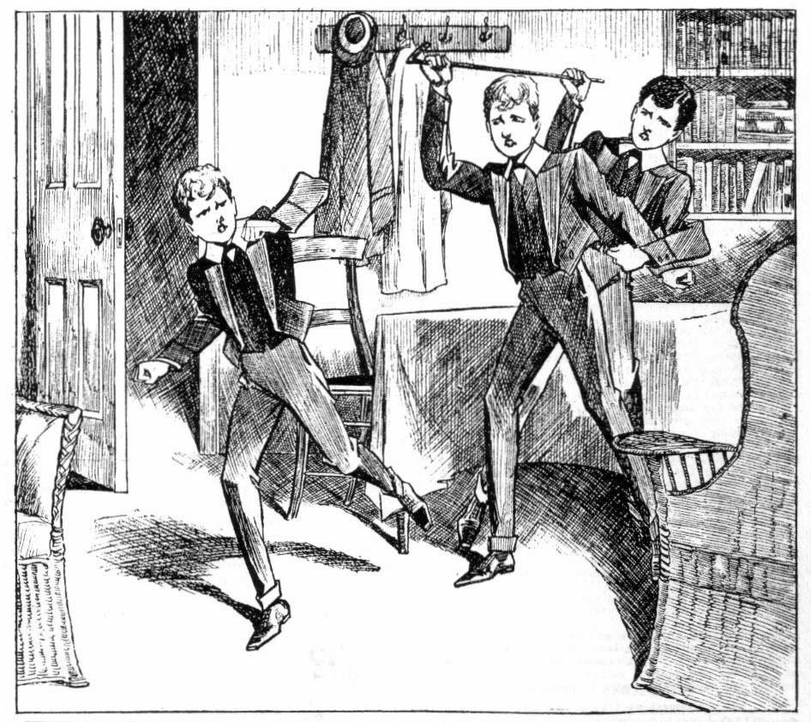
“Let me go!” panted Nugent, wrenching his arm away. The young cad wants a licking, und he’s going to have it!”
Wharton grasped the cane and jerked it away.
“He’s had enough, Frank! Don’t be a brute!”
“Let me alone!”
“Cut, Dicky!”
Wharton held his infuriated chum, while Dicky Nugent, half sobbing, fled from the study.
For a moment Nugent clenched his hands, as if he would turn upon Wharton. Harry looked him calmly in the face.
“Cheese it, Frank!” he said quietly. “Don’t be an ass!” There’s nothing for us to quarrel about!”
Nugent dropped his hands, panting,
“You shouldn’t have have interfered.”
You were going too far, Frank. Remember, he’s only a kid, whatever he’s done. It isn’t like you to be a brute.”
Nugent burst into a bitter laugh.
“The young rascal ought to be skinned.” he said. “You don’t understand—”
“Well, what has he done?”
Nugent did not reply. “
“I don’t understand you lately, Frank.” said Wharton uneasily. “This is the second time you’ve lost your temper today—over nothing, so far as I can see. What’s the matter with yon? You were very rough on Ponsonby. Yes; I know he’s an out-and-out cad—but there’s a limit, all the same. Now you are thrashing your minor, and you won t say what he’s done. It’s getting too thick.”
“He has wanted a licking for a long time.” said Nugent, breathing hard. “If I’d licked him before, he mightn’t have done this.”
“Done what?”
“What’s he done?” said Nugent savagely. “ Never mind what! But, if you must know, he’s on the right road to being sacked from the school, and bringing disgrace on all the family. And he won’t listen to me.”
Wharton wrinkled his brow.
“That doesn’t seem like Dicky,” he said uneasily. “ He”s a good enough little chap. If he’s done anything rotten I’m pretty certain he’s been led into it by some other chap who ought to know better. That’s the chap you should go for.”
Nugent was silent.
And licking a kid like that is more likely to make him obstinate than anything else.” said Wharton.
“Oh, don’t preach at me!” said Nugent wearily, throwing himself into a chair. It’s bad enough without that.”
“Well, I don’t want to preach, Frank. But—”
“That’s enough, for goodness’ sake!”
“Oh, all right!”
Wharton left the study, his brow clouded. His own temper
was not of the gentlest, and his study-mate was trying it sorely. But when the Removites went up to their dormitory a little later, Nugent touched Wharton’s arm.
“Sorry, old man!” he muttered. “ Don’t mind my flying out ! But—but. I’m worried, and— and I don’t want to talk about it. Don’t mind what I said.”
Wharton’s face cleared at once.
“All serene, Frank!”
“It’s not a pleasant prospect for to-morrow morning, you know.’’ Nugent added, with a grimace. “It’s getting on my nerves a bit!”
“I understand that, Franky. I wish we could whack it out among us.” said Wharton dismally.
Nugent laughed, and the subject was dropped. The Remove turned in. But it was a long time before Frank Nugent slept: and when he fell into slumber at last, it was to dream of the ordeal that waited him in the morning.
THE SIXTH CHAPTER.
The Flogging!
HARRY WHARTON & Co. wore worried looks when they came down on the following morning.
Frank Nugent was very quiet and subdued; indeed, he looked less worried than his chums.
The Co. seemed to take his punishment more to heart than Nugent himself.
Harry Wharton had been thinking the matter out carefully. Under the circumstances the Head could hardly have come to any other decision: but Wharton felt sure that Nugent, if he chose, could explain his action and escape the humiliation of a flogging. Why Nugent was keeping silent was a mystery. When they came down that morning, the captain of the Remove tackled him on the subject, making one more effort to make him see reason, as he termed it.
“Look here, Franky,” he began. “ You needn’t tell us about it, if you don’t want to; we’re not curious. But 1 know you must have had some good reason for licking Ponsonby. Why can’t you tell the head, and get off the flogging? If you could make a good excuse, the head would let you off.
Nugent nodded.
“Well, you had a reason, I suppose?” exclaimed Bob Cherry.
“A jolly good reason!” said Nugent.
“Good enough to satisfy the Head?”
Nugent smiled faintly.
“Yes, I think so—if I told him.”
“Then why not tell him!”
“I can’t.”
“But why not?” demanded Johnny Bull.
“It’s impossible, that’s all. ”
You’re jolly mysterious!” growled Bull. “I’m blessed if I like the way you’ve got of keeping secrets, Nugent! It’s
not pally!”
“I can’t help it!” said Nugent, colouring. “I’d tell you
—only I—I don’t want to. It s a private matter, and I don’t care for anybody to know about it.”
“But if you could get off the flogging by telling the Head—”
“It’s impossible. It would make matters worse.”
“How!”
“Never mind how. It would, that’s all! And never mind the flogging; I can stand it.”
And Nugent walked away to avoid further argument. His chums looked at one another, worried and a little exasperated. This obstinacy and secretiveness were something new in Frank Nugent.
“I’m blessed if I can catch to this.” said Bob Cherry, with a grunt. I can’t see at all what Ponsonby can have done to gpt Franky’s back up like that. And why can’t he tell his own chums? I don’t like it! And if one of us gets a flogging, it reflects on all of us. Bunter and Snoop and Skinner are cackling about it already.”
“Let me catch ‘em cackling!” growled Johnny Bull, clenching his eight fists.
“Look here!” sid Harry Wharton abruptly. “We can’t let Franky go through this if it can be helped. I’m going to the Head!”
“Phew!” What good will that do?”
“None, very likely, but I’m going to try it.” said Harry.
“You fellows can come with me if you like.”
“Oh, we’ll come!” said Bob. “But I don’t see that it will do any good. The Head won’t take our opinion on the subject. ‘
The Co. made their way to the Head’s study, and Wharton knocked at the door. Dr. Locke was talking to Mr. Quelch when they came in. Both the masters were looking very serious, and Wharton guessed that they were discussing the flogging that was to take place after payers. Unpleasant as the prospect was for Nugent, it was not much more pleasant for the Head, who disliked and seldom inflicted corporal punishment.
“What is it, Wharton?” asked the Head abruptly.
“If you’ll excuse me, sir, I—I want to speak about Nugent.” said Wharton, colouring under the head’s gaze. “He is going to be flogged—”
“Well?”
He won’t tell us why he went for Ponsonby, sir, but—but perhaps if you made him explain, it would be all right. We know he must have had some good reason for what he did; he wouldn’t act like that for nothing. He’s the best tempered chap in the Remove, sir. And we all know that Ponsonby is rotten cad—an utter rotter, sir. He must have done something utterly rotten to make Nugent so wild yesterday, and—and I think Nugent won’t explain, because he thinks it would be sneaking, or something like that.”
“I am afraid that nothing could justify Nugent’s taking the law into his on hands in this way, Wharton,” said the Head quietly, “and I am afraid that any explanation would now
come too late. Nugent had his opportunity yesterday, and he refused to speak—if he had anything to say. I have now passed my word to Mr. Mobbs that Nugent shall be flogged for the assault upon Ponsonby. There is nothing more to be
said.
“But, sir—” said Wharton miserably.
“I am afraid I cannot listen to anything further on the subject, Wharton. ” said the Head, not unkindly.
There was nothing more to be said. The juniors withdrew with glum faces from the study.
“Nothing doing!” groaned Bob. “Poor old Franky’s going to get it in the neck!”
And a little later the school was assembled in Big Hall for the flogging.
The whole school was there, from the Sixth down to the smallest fags, ranked in their Forms to witness the punishment of the Removite.
Frank Nugent was in his place with the Remove, when the Head came in by the upper door.
There was a hush in the big hall.
Gosling, the porter, whose duty it was to “hoist” the victims on such occasions, came in with his heavy tread. Gosling did not seem to share the general glumness. Gosling’s amiable opinion was that the more boys were flogged, the better it was for them, and he was cheerfully ready to lend his assistance.
“Nugent, come up here!”
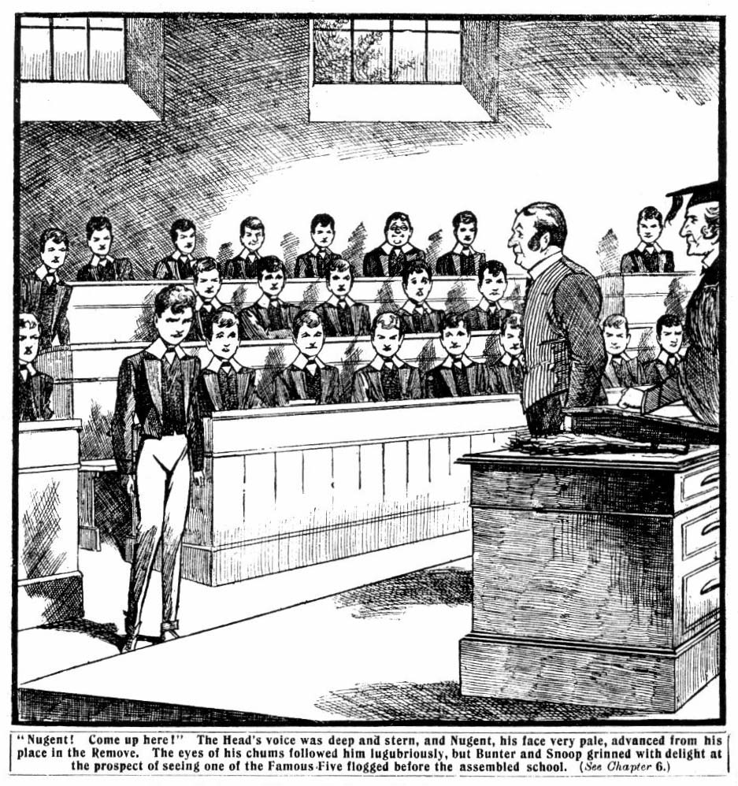
The Head’s voice was deep and stern.
Nugent, his face very pale, advanced from his place in the Remove.
The eyes of his chums followed him lugubriously. There were two grinning faces among the Removites. Bunter and Snoop seemed to think there was something amusing in a flogging inflicted upon a member of the Famous Five. Johnny bull noted their expressions, and mentally made them promises of some thing to happen when the assembly was dismissed.
“Nugent”—the Head’s stern voice was audible throughout Big Hall— “you have a disobeyed my commands, and committed what was apparently on unprovoked assault upon a boy belonging to a Highcliffe School. You have not been able to offer the slightest excuse in extenuation of your conduct. 1 am about to flog you, and I trust the punishment will be a warning to you in the future!”
Nugent did not speak.
The Head made a sign to Gosling, who advanced to “hoist” the junior. Nugent clenched his fists for a moment, and unclenched them again. Apparently the thought of resistance had passed through his mind, only to be dismissed at once. He submitted quietly.
Goslig took him up.
Through the silence of Big Hall the lashes of the birch sounded clearly and distinctly.
It was a severe flogging, but no sound came from Nugent’s lips. His face was pale, his teeth hard set, his eyes gleaming. If the punishment had been doubly as severe, he was determined that no cry should be wrung from his lips.
Hardly a sound was heard in the crowded hall.
The last blow was delivered, and Nugent was lowered from Gosling’s back. He slipped to his feet, and stood a little hesitantly, his face white as chalk, his eyes burning.
The Head’s glance was compassionate. He had done his duty, and it had been a painful duty to him.
“You may go!” he said quietly.
Nugent went without a word.
The Head made a sign, and the assembled school dispersed. Nugent’s chums gathered round him as he walked unsteadily from the hall.
They did not speak; there was nothing to say. He knew that they felt for him, and that was enough.
Nugent went up to his study. He wanted to get out of sight just then. On the stairs his chums left him; he wanted to be alone. Johnny Bull turned back, with a glitter in his eyes. He had not forgotten Bunter and Snoop. Those two precious youths were in the lower hall, and they were grinning. They ceased to grin as Johnny Bull came striding up to them.
“What’s the joke—eh?” asked Johnny, his voice thick with anger. “Funny to see Nugent flogged—what? You rotters!”
“I say—” began Bunter, backing away.
“Look here——” muttered Snoop.
They had no time to finish. Johnny Bull grasped them both at once by the collar. The two juniors wriggled in his muscular grip.
“Leggo!” howed Bunter. “Look here—”
“Hands off!” yelled Snoop. “I think it served him jolly well right, if you want to know! Let go ny collar, you beast!”
Crack!
Johnny Bull did not let go. He brought the two heads together with a sounding concussion.
“Yarooh!”
“Yow-ow-ow!”
Crack!
“Ow ! Ow ! Help !”
“Yah! Oh! Oh! Oh!”
“Now you can cackle as much as you like!” grunted Johnny Bull. “You’ve got something to cackle about now, you cads!”
And with swing of his powerful arms the sturdy junior
sent Bunter and Snoop stumbling away, to collapse in a heap by the wall. Then he strode away. Billy Bunter sat up, and blinked through his spectacles at the grinning juniors.
“Ow! Ow! Bull, you beast—yow! —I’ll jolly well slaughter you for that! Ow!”
“Go after him and slaughter him!” grinned Bolsover major.
“Yow-ow-ow!”
“Groo-hooh!” groaned Snoop.
They picked themselves up, but they did not go after Johnny Bull to slaughter him. Johnny Bull was the last person in the world they would have cared to tackle just then. They rubbed their heads and breathed vengeance. The bell rang for classes, and the Remove went into their Form-room, Nugent coming in a little late.
But Mr. Quelch made no remark on his unpunctuality. Mr. Quelch was generally very strict upon that point; but he was
a tactful master, and he knew when to close his eyes, and he passed over Nugent very lightly that morning.
THE SEVENTH CHAPTER.
Nugent’s Does His Duty!”
“I SUPPOSE you’re playing this afternoon, Frank!”
Harry Wharton asked the question when the juniors came out of the Form-room after morning lessons. It was a Wednesday, and a half-holiday at Greyfriars and the Remove cricketers were meeting the Shell.
Nugent hesitated.
“Yes, I suppose so.” he said. “I—I’ve got something else to attend to, but I shall be able to play.”
“The club accounts, do yu mean?” asked Harry. “That won’t take long, and I’ll help you with them if you like. Milson’s bill has come in, hasn’t it?’’
“Yes: and it’s got to be settled to-day. But it wasn’t that I was thinking of. But it’s all right I’m playing!”
Wharton did not ask his chum what it as that he had to do. If Nugent chose to be secretive, that was his business: and Wharton was not curious.
Nugent had taken his punishment very quietly, but the juniors knew that he had not got over the flogging yet. At dinner he was very subdued. Once or twice he glanced over to the Second Form table towards his minor. But Dicky Nugent did not meet his glance. Dicky was looking sullen.
The licking Frank had given him the previous evening had completed the breach between the two brothers. If Dicky came into contact with his major now, he passed him with a scowl, and without a word. And Frank’s feelings seemed
to be equally bitter. But when the fellows came out after dinner, and Dicky Nugent cut to the Second Form-room, Frank followed him there.
Dicky looked round as his major came in, and eyed him savagely. They were alone in the Form-room.
“Well, what do you want now, you bully?” said Dicky, between his teeth.
Nugent coloured hotly.
“Don’t call me that, Dick. You know as well as I do that you asked for that licking!”
“Oh, cheese it!” Have you come to ask me for my promise again got to speak to Ponsonby?” said the fag, with a bitter sneer. “Because I won’t give in!”
“You ought to, Dick.”
“Rot!”
“What do you think the pater and mater would say if they knew the kind of thing you were getting into, Dick?” said Nugent, controlling his temper.
“I don’t know, and I don’t care either!”
“They would put the blame on me—you know that!” said Nugent bitterly. “I’m supposed to be looking after you here !”
“I’d rather you minded your own business!”
“I t’s my business to look after you, Dick, and save you from getting the sack, whether you like it or not!”
“Oh, rats!”
“I won’t ask you for your promise again, Dick!” said
Nugent, his voice trembling. “You won’t give it, and there’s an end. But you’ve got to stop seeing Ponsonby. I know he will try to keep on with you, and get you deeper into his rotten ways, to get even with me for licking him. I’m sure of that!”
Dick laughed scoffingly.
“Then you haven’t improved matters much by meddling.”
he said.
“But I’m going to stop it, Dick: I’ve got to. If you meet Ponsonby again, I’m going to lick him—and I shall give you the same again!”
“And get another flogging!” sneered the fag.
“I’ve got to risk that!”
“It mayn’t be a flogging next time!” said Nugent minor. “The Head may sack you next time, if you go and make a row at Highcliffe!”
“I shall risk that, too.”
“I jolly well wish you were sacked!” burst out the fag passionately. Less “There would be an end of your meddling with me, anyway.
Nugent gritted his teeth.
“We won’t talk about that, Dick. So long as I’m here, at any rate, I’m going to do what I think is my duty.”
“Oh, cheese that! I don’t want any sermons from you.”
“Dick—”
What have you come here for!” demanded the fag resentfully. “Are you going to watch me about, and spy on me all the time?”
“I want you to open your locker.”
“What for?”
“I want to see what’s in it.”
“You want to spy, you mean!”
Nugent clenched his hands.
“You’d better not tempt me too far, Dick. It’s not easy for me to keep my hands off you as it is!” he said thickly. “ I’ve heard the fags talking about you. Sammy Bunter told his major that you kept a pack of cards in your locker.”
“Hang Sammy Bunter!”
“Hang him as much as you like. But is it true!”
“Mind your own business.”
“Do you know, you young fool, that it’s enough to get
you sacked!” broke out Nugent fiercely. “I haven’t told the
Head why I thrashed Ponsonby. I haven’t told Wharton why
I licked you last night, and he thinks I’m a brute. But if it
once comes out what you are doing, I sha’n’i be able to save
you. Let the masters or the prefects get on the track, and
the whole story will come out. Do you want to get the sack, and to be sent home in disgrace? Haven’t you a little sense? ”
“I can look after myself !”
“Open your locker!”
“I won’t!”
Nugent crossed over to the locker. It was locked. Dick Nugent eyed him with sullen malevolence.
“Give me the key, Dick!”
“I won’t!”
“Very well: I’ll smash it open.”
Dicky Nugent’s eyes flamed.
“You—you don’t dare! You’d have to explain what the locker was smashed for—”
“If I have to explain that, it will come pretty hard on you.” said Nugent grimly. “Give me the key!”
“I won’t!”
“That’s enough!”
Nugent major picked up the heavy iron poker from the grate, and returned to the locker. His minor watched him with a furious eyes. Without another word Frank raised the poker.
“Stop it!” shouted Dicky. He flung the key savagely on the floor. “There you are, you rotten spy!”
Nugent picked up the key and placed it in the lock. Dickie, his hands trembling with rage, watched him open the locker.
Nugent went through it grimly. He turned out a pack of cards in a cardboard case, and a packet of cigarettes. Dick was evidently learning more than one of the peculiar amusements of Cecil Ponsonby. .
“So you’ve taken to smoking, Dick?”
“Find out!”
Nugent put the cigarettes and the cards into his pocket. He searched the locker carefully, but nothing else came to light of the same nature. He locked it again, and threw the key back to his minor.
“That will do!” he said. “I shall burn these cards, and the cigarettes, Dick; and I wiI1 look in your locker every day to see if you have any more.”
“Spy!”
“And if you meet Ponsonby again I’ve told you what I shall do. And if you pay him a cent of the money he’s swindled you out of, I’ll make him sorry for it. That’s all!”
“ I’m going to pay him every penny.” said Dicky. “It’s a debt of honour. I suppose you don’t understand what honour is. I’m going to pay him, wherever the money comes from. I’ll get it somehow—I don’t care how—and I’ll pay him!”
“ Nugent did not reply. He quitted the Form-room in silence. He passed Gatty and Myers in the passage, and the two fags looked curiously at his moody face. Then they came into the Form-room; they were looking for the chum.
“Oh, here you are, Dick!” exclaimed Gatty. “I wondered where you had got to. I hope you haven’t forgotten we’re playing the third this afternoon.”
“Eh, what?” growled Dick.
“You’re in the team, you know!” said Gatty. “ Come along!” ‘
“I’m not playing this afternoon!”
“But you’ve got to play!” exclaimed Gatty, in surprise and wrath. “Who’s skipper of the Second Form, I’d like to know!”
“I’m not playing!” said Nugent minor doggedly.
“Oh, draw it mild, Dick!” said Myers. The Third are
in great form, you know; we can’t possibly spare you. Bolsover minor and Paget and Tubb and young Wingate make a pretty tough handful; and we can’t leave out our best bat.’’
But the soft answer failed to turn away wrath in this instance.
“I’m not playing!”
Gatty frowned darkly.
“Look here, young Nugent, I’m skipper of the Second, and I tell you you are to play!” he exclaimed angrily.
“And I tell you I can’t!”
“You mean you won’t?”
“ Well, I won’t then, if you prefer it like that!” growled Nugent minor.
“Then I tell you—”
“Easy does it it!” said Myers soothingly. “Don’t row. What’s the matter, Dick? You’ve not got anything special
to do this afternoon, have you?”
“Yes.”
“Well, what is it, then?”
“I’m going out!”
“Going out!” snorted Gatty. “What for? Is it the Highcliffe fellows again? Is Ponsonby going to teach you how to play billiards, and rook you over it?”
“Mind your own business!”
Dick Nugent walked to the door. Gatty looked greatly inclined to rush upon him, and finish the argument with his knuckles but Myers restrained him.
“Well, look here” roared Gatty. “if you don’t play this afternoon when we want you, you won’t play in the team again at all!” Understand that!”
“I don’t want to.”
“You—you silly chump! Are you going to cut cricket?”
“Hang cricket!”
And Nugent minor swung out of the room. Gatty and Myers stared at one another in angry surprise and consternation.
“Well, this beats the giddy band!” said Myers. “What’s come over him?”
Gatty snorted.
“Well, he’s out of the eleven.” he said. “I can’t play him again, anyway. If he stays out to-day, he can keep out. And he can go and eat coke! I’m done with him!”
And Gatty stamped away in a rage. But Dick Nugent was not thinking of his olds chums in the Second Form, whom he was treating in so cavalier manner. He had other matters to think of, and he did not give the Form match of his chums in the Second a thought.
THE EIGHTH CHAPTER.
Wun Lung on the Watch!
“Oh, rotten!”
“Butterfingers!”
“Yah!”
“Go home!”
Frank Nugent flushed hotly. Those uncomplimentary remarks from the Remove fellows crowded on Little Side hailed upon him with many more of the same sort. And it could hardly be denied that they were deserved.
The remove were playing the shell, and Harry Wharton & Cole were in the field. Hobson of the Shell had just driven the ball with a mighty swipe fairly into Nugent’s hand. And Nugent, generally one of the most reliable of fieldsmen, had moved the catch. It was an easy one—Billy Bunter would hardly have muffed it, if he had been in Nugent’s place—and Nugent had allowed it to fall to the ground.
And the shouts of the Remove fellows round the field told what they thought of his performance.
Nugent was crimson as he picked up the ball and sent it in.
He knew that he was playing rottenly, but he could not help it. He was utterly out of sorts. It was not merely the flogging
of the morning; physically he had got over that. But it had left his nerves in a jarred state and he had a worry on his mind. While he was playing cricket on Little Side at Greyfriars, what was his minor doing? To spend the half- holiday in watching Dick— practically, in playing the spy on him — was too repugnant to Nugent’s nature for him to think of doing it it. And yet, was it right for him to be there playing cricket, while his young brother was only too probably being led into further rascality by the reckless young blackguards of Highcliffe School?
If Dick’s recklessness le—as it must lead in the long run
—to coming a “cropper”—if he were sacked from the school for disgraceful conduct Nugent knew that most of the blame
would be laid to his charge at home. It would be held there, as Dick’s major, he ought to have looked after him and kept him away from bad ways. And it was true enough, in a way.
It was his duty. But some duties are very difficult to do; and Frank did not see what was to be done. In such a frame of mind, Nugent was not likely to put up a good game on the cricket field.
He was doing his best, but he could not help his thoughts wandering. Wharton gave them a quick look as he returned the ball, but he did not speak. Wharton was a good skipper, and had tact. But the skipper who rags his field in the progress of a game is not the kind of skipper to win matches.
Under Wharton knew, too, that there must be something wrong with his chum—something more than the effects of the flogging. Nugent had some trouble on his mind—something he had not chosen to confide to his chums.
The Shell fellows were grinning. As a rule, they found it very difficult to beat the Remove, though they were, of course, an older team. It’s looked as if the task would be easier on this occasion.
Hobson, who ought to have been out, went on batting, and he did not give Nugent another easy chance. And the runs piled up—runs that never ought to have been taken, if
Nugent had made that catch.
Dick Nugent, from the elm trees in the distance, out of sight of his major, was watching the play. He was not interested in the Remove match, however. The fag’s object was to see that his major was included in the team, and therefore occupied for the afternoon. Dicky grinned in a sneering way as he saw the muffed catch. The fag was evidently entirely out of sympathy with his major.
He turned and walked away. He did not give a single glance towards the further field with the second were playing the Third. Dick Nugent had always been a keen cricketer, and a tower of strength to Gaddy’s juvenile eleven. But under the influence of the estimable Ponsonby & Co, he was losing his taste for cricket—preferring to “see life.” as the Highcliffe fellows termed it. Seeing life, for Dicky, appeared to amount to playing cards in some secluded spot, and losing call his available cash to Ponsonby & Co., and handing them I.O.U.’s for sums he could not possibly pay. But that is not an uncommon way of “seeing life.”
The fag entered the School House, looking round him in a peculiarly cautious manner. The house was deserted on that sunny half holiday. Almost all the fellows were on the playing fields or the river; and the masters were out of doors. Dick Nugent did not go towards his own quarters. He ascended the stairs, and the entered the Remove passage.
The passage was quiet as a churchyard.
From the distance, through the open windows, came the shouts from the cricket-ground, but there seemed no one about in the house.
Some of the study doors were open, but the studies were evidently unoccupied. The whole place seemed deserted.
The fag paused in the passage, his heart thumping violently, and a strange paleness in his face. But his expression was dogged, almost desperate.
He had stopped outside the door of No. 1 Study—the room his major shared with the captain of the Remove.
But he hesitated to enter.
There was a step on the stair, and Dick Nugent started. A caller flooded his face as little Wun Lung, the Chinee, came up, and passed him in the passage. He made a pretence of looking out of the passage window.
Wun Lung glanced at him coldly.
The little Chinee, sleepy as he looked, was a keenly observant youth, and he could not fail to note the flush in Dicky’s face, and his disturbed and troubled manner. And he knew that Dicky was only pretending to be interested in the view from the window.
A Second Form fag had no business in the Remove quarters at all; and Dicky could not have come there to see his major, who was on the cricket field. Wun Lung grinned. He had heard of Dicky's licking on the previous evening. Wun Lung was as full of tricks as a monkey; and when he was licked— which was not infrequently—he generally contrived to indemnify himself by playing some peculiar prank on the enemy. And he jumped to the conclusion at once that that was what was in the fag’s mind. That accounted for his presence in the Remove passage while all the fellows were out, and for his evident confusion at being discovered there.
“Goodee aftelnoon!” said Wun Lung affably.
Dick Nugent grunted.
“Nicee finee day!” pursued Wun Lung urbaney.
“Yes” growled Dicky.
“No playee cricket?”
“No!”
“P’l’aps playee trickee?” grinned Wun Lung.
Dick glared at him.
“What do you mean, you Chinese image?” he broke out angrily. “What are you talking about, you pigtailed heathen.
“No be angry wiz Wun Lung!” nurmured the little Chinee depecatingly. “Allee lightee! Me knowee whatee for.”
Dick started violently. But he recovered himself, as he saw the little Celestial’s almond eyes watching him intently.
“I—I came to speak to my major!” he said lamely.
“Nugent majee playee cricket.”
“Well, I’m waiting for him.”
“Playee longee time.” chuckled Wun Lung.
Dick grunted.
“Me savvy whatee wantee. Playee trickee, because majee lickee—what?”
“Oh, rats!”
“No playee tlickee on majee.” said Wun Lung seriously, with a shake of his queer little head. “Not goodee. Nugent major goodee chappy. Better not. What you tinkee?”
Dick Nugent scowled. He understood what the Chinee meant. Wun Lung supposed that he had come there to play a trick on Nugent major, in retaliation for the licking, and was trying to dissuade him. Wun Lung was acting in the role of a peacemaker. He was far from guessing what was really in the fag’s mind; but Dick Nugent realised that it was better to leave him in his mistake.
“All right!” he said suddenly. “You’re right!” I’m off!”
And he went downstairs.
Wun Lung looked after him curiously. The little Chinee was very much attached to the chums of No. 1 Study, who had often stood between him and raggers. He liked Frank Nugent best of all his Form-fellows. He would have been glad to prevent the evident trouble between the brothers from becoming worse; but he did not believe that Dicky Nugent was gone for good. He had simply gone, with the intention of returning when the coast was clear. Wun Lung grinned at the idea of the fag thinking that he could deceive him——the deep and cunning Oriental. He could read Dicky Nugent like au open book.
“Velly baddee!” murmured Wun Lung. “Dickee playee
tlickee on Flankee— Flankee whackee again—velly badee! Me savvy!”
Wun Lung walked along the passage to his own study,and slammed the door, far Dick Nugent to hear as he waited
downstairs. Then he tiptoed back to No. 1 Study, and slipped in, closing the door softly.
There was a screen in the corner of the study— not a large one, but ample to cover the diminutive Chinee. Wun Lung slipped behind it.
With a contented grin, he crouched in the corner, hidden from sight.
Wun Lung was a somewhat peculiar youth. His gift for lying excelled that of Billy Bunter, who was popularly supposed to be able to beat Ananias in his own line. And any amount of hammering had not been able to knock into him the least regard for the truth. The tricks he sometimes played were extraordinary, and earned him many lickings. He was a skilful conjurer, and in sleight-of-hand he equaled many professional exponents of the art, and when fellows found themselves with other fellows’ watches in their pockets, they went for Wun Lung at once, and hammered him.
But with all his Oriental duplicity, and his peculiar tricks, the little Celestial really had a heart of gold—and when he was attached to anyone, there was no amount of trouble he would not take to show his devotion.
And now he cheerfully gave up his half-holiday, with the idea of counteracting any trick Dick Nugent intended to play in his major’s study, intending to prevent the trouble between the brothers going from bad to worse.
And he had a good time to wait.
That the fag would return he felt sure, but an hour passed away before Dicky Nugent came. Wun Lung, ensconced behind the screen in the corner of the study, grinned as he heard a cautious footfall in the passage.
The handle of the door was turned softly.
Wun Lung scarcely breathed.
The door opened. From behind the screen he could not see the fag, but he knew that he had entered, and he heard the door softly close again.
The fag was in the study.
Wun Lung listened with all his ears. He heard the fag
stop at Nugent major’s desk in the opposite corner. Then he
ventured to peep out, knowing that Dick Nugent’s back
would be towards him.
Dick Nugent was standing at his major’s desk, fumbling
in it.
He made a movement, and Wun Lung whipped back out of sight.
He chuckled silently.
Whatever mischief Dicky might do, Wun Lung intended to undo it after he was gone, and Frank would not know that a ragger had been there.
But Wun Lung almost jumped as he heard the fag cross hastily to the door, and quit the study.
The door closed.
Wun Lung looked out from behind the screen.
Save for himself, No.1 Study was empty.
The Chinee looked round him with a puzzled expression. He glanced at the desk and opened the lid and looked in. Everything seemed in order.
“Great Scottee!” murmured Wun Lung, mystified. “ No comee to laggee studee. Whatee for comee at all?”
He stood for some moments in thought. Dick Nugent’s footsteps had died away down the passage and the stairs.
Wun Lung looked from the window, and saw the fag come out of the house, and started. Dick Nugent’s face was white as chalk. He hurried across the Close in the direction of the school gates.
Wun Lung’s expression changed.
What had the fag done at his major’s desk— the desk where Frank Nugent kept the funds of the Remove cricket club? The little Chinee breathed hard. From his minor, Hop Hi of the Second Form, he had heard the resentful chatter of the fags about Nugent minor’s new friendship with the Highcliffe fellows; and he knew what the friendship was likely to lead to. Was it possible——Wun Lung’s look was very grave now.
“Pool old Flankee!” he muttered. “Young lascal! Me thinkee me savvy!”
The little Chinee ran quickly out of the study, and slid down the banisters. Without stopping a moment, he scudded across the Close, and as he reached the school gates and looked out, he caught sight of Nugent minor again, tramping doggedly away in the direction of Highcliffe school.
Wun Lung, with an air of careless unconcern, but with his almond eyes glinting, sauntered in the same direction.
THE NINTH CHAPTER.
Dark Doubts!
“BEATEN to the wide!” grunted Bob Cherry.
The Form match had ended.
Hobson & Co. of the Shell had won by twenty runs, and the Remove were defeated, and they were annoyed.
True, the Shell were an older Form, and such a match was really a “big order” for the Lower Fourth. But the Remove fellows were keen cricketers; they had often beaten the Shell, and they had expected to beat them again. And it could not be denied that but for Frank Nugent’s unaccountable slackness, they would have beaten them, for Hobson had taken twenty one runs after that catch which was not a catch. If Nugent had caught him out at the critical moment Hobson’s score would have stopped there, and the victory would have been to the Remove.
Frank realised that as keenly as the other fellows did, and his handsome face was moody as he came off the field with his chums.
Wharton did not mutter a word of reproach. That was not his way. But a good many of the fellows in the team were grumbling.
“The beatfulness was terrific!” remarked Hurree Jamset Ram Singh. “But we have beaten the esteemed Shell many times, my worthy Bob!”
“Ought to have beaten them this time, too grunted Tom Brown, the New Zealand junior. “ If Nugent hadn’t muffed that catch—”
Nugent coloured.
“Don’t rub it in!” he said, “I know I’ve played rottenly.”
“Well you have, and no mistake!” said Bulstrode. “ You were bowled for a duck’s egg, too. Where were your wits?”
“It might happen to anybody!” said Wharton. “I’ve been bowled for a duck’s egg before now, and so have you, Balustrade.”
“I’ve never rnuffed a catch like that!” growled Bulstrode.
“Chucking the match away, by gum!” said Ogilvy.
“Oh, cheer up, and don’t cry over spilt milk!” said Peter Todd. “We’ll lick the Shell next time, anyway!”
“Next time ain’t this time!” snorted Bulstrode. “We really won the match, only Nugent—”
“Oh, rats!” said Nugent. “Let’s hear an end of it! I’m fed-up !”
And he walked quickly away.
His chums followed him quickly into the House. Nugent’s face was moody and wrinkled. He had taken the loss of the cricket match very much to heart, though that was certainly not the only matter weighing on his mind.
“Don’t bother about it, Frank.” said Wharton, as they came into No. 1 Study. “ Sometimes a fellow gets off colour, and it can’t be helped. It was really my fault for playing you I ought to have seen you weren’t fit. Dash it all, it doesn’t matter much, anyway! Let’s have tea.”
“I lost the match for you!” muttered Nugent.
“Well, that’s how it turned out; but it’s nothing. It wasn’t a blessed county match with a championship at stake.” said Wharton, laughing. “ and it wasn’t a big fixture like our match with Redclyffe or St Jim’s. Don’t bother about it. Now then, what about tea?”
The juniors were quite ready for tea, though the match had finished unexpectedly early. Bob Cherry and Johnny Bull had stopped in the tuckshop for supplies. They came in with the supplies, and the Famous Five prepared tea in No. 1 study. Nugent was very quiet and subdued.
“For goodness’ sake, cheer up, Franky!” said Bob Cherry, when tea was over, and Nugent had spoken hardly a word. “ You’re not worrying over that catch still, are you?”
“That catch! No.”
“You’ve got over the licking, surely?”
“Eh? I’d forgotten that.”
“Then what’s the matter with you?” exclaimed Bob. “ I suppose you haven’t got anything on your mind, have you?”
Nugent flushed
“If you have,’’ grinned Bob “ you can confide it to your Uncle Robert. Pile in!”
“Oh, don’t be an ass!” said Nugent.
“Thanks! Look here, you’re not going to mope about like that!” said Bob. “Come into the gym, and have a go at the
bars.
“Oh, rot!” ‘
“Ahem! I must say you are cultivating some beautifully civil manners and customs!” said Bob, still good humoured. “Are you always as polite as that when you have a fellow in to tea?”
“Oh, cheese it, please!”
“Hallo, hallo, hallo!” Here’s Bolsover!” said Bob.
Bolsover major came into the study. There was a dogged and determined expression upon Percy Bolsover’s face, and the chums of the Remove were prepared for trouble at once. Bolsover, the biggest fellow in the Form, was the bully of the Remove, but he never ventured to bully the Famous Five. But it certainly looked now as if he had come to seek for trouble. Bolsover had a claim to be played in the Form team, and he was extremely “ratty” at being left out on most important occasions, declining to admit that the fellows in the team were any better players than himself.
“Well, what’s the row, Bolsover?” asked Wharton.
“I want to speak to you, as skipper of the cricket club.” said Bolsover. “I asked you to play me this afternoon.”
“And I couldn’t do it.”
“You wouldn’t, you mean.”
Wharton shrugged his shoulders.
.. “Wouldn’t, if you prefer it that way.” he replied. “Put it as it suits you. I don’t mind!”
“We’re playing Redclyffe on Saturday, said Bolsover, “and I want to know—and some of the other fellows want to know—whether you will be playing that silly ass!”
And the bully of the Remove pointed to Nugent.
Nugent turned crimson.
“Because if you do, there’s going to be trouble!” said Bolsover truculently. “Nugent muffed a catch today that Bunter himself wouldn’t have muffed. Nugent threw the game away. Do you mean to say that I should have done any
worse!”
“As it turns out, probably not.”
“Wouldn’t I have done better?” demanded Bolsover.
“Possibly.’’
“Well, then, will you leave Nugent out on Saturday and play me against Redclyffe !” demanded Bolsover.
“No, I won’t!” said Wharton tersely.
“After what he’s done today—”
“Oh, go and eat coke!”
Bolsover are turned red with anger. As a matter of fact, he might have made out a good claim, if he had approached the matter in a less truculent manner. He could scarcely expect the cricket captain of the Remove to allow himself to be bullied into making the arrangements for the junior matches. But that was Bolsover’s manner. It had always been a sore point with him that he could not ride roughshod over the Famous Five, as he did over a good many fellows in the Lower Forms.
“There’ll be trouble about it!” growled Bolsover. “If you’re thinking about playing that silly dummy again—”
Nugent’s sprang to his feet. His temper had been sorely tried lately, and he was not in the humour to be slanged by the bully of the Remove.
“That’s enough, Bolsover!” he exclaimed sharply. “If you can’t keep a civil tongue in your head, get out of the study!”
Bolsover major 1ooked at him with a sneer.
“I called you a dummy,” he said. “and you are a dummy! A fellow who would muff a catch like that is a dummy, and a silly chump, and a howling ass, and— Oh, would you? Come on, then!”
Nugent had rushed at him, with blazing eyes. Bolsover major put up his hands at once. He was not sorry to provoke one of the Famous Five into conflict, especially one of the least formidable of the Co.
The other juniors were on their feet now.
“Chuck the brute out!” exclaimed Bob Cherry.
Nugent closed with Bolsover major, but athletic as he was, he was no match for the burly Removite. Bolsover major swung him off his feet, with a sneering grins and strove to pitch him out of the study. But Nugent came down actively on his feet, still holding on to the bully, and with a wrench he dragged Bolsover over. The two juniors went to the floor
with a crash.
They rolled over on the floor furiously, pummeling one another. Then the chums of the Remove descended upon
them, and dragged them apart. Bolsover major, grasped by four pairs of hands, was flung headlong into the passage, and he rolled over there with a grunt. Bob Cherry slammed the door after him.
“So much for Bolsover!” grinned Bob Cherry. “Hallo, hallo, hallo!” What the deuce is this!”
Nugent staggered, panting, to his feet. But Bob Cherry’s eyes were fixed in astonishment upon three or four playing-cards that lay scattered on the carpet, with several crushed cigarettes among them. They had evidently been dropped their by one of the combatants, having come out of a pocket while the two juniors were struggling and rolling on the floor.
“Bolsover ought to be a bit more careful with his property.” grinned Bob. “If a prefect saw him dropping these things about, it would mean trouble.’’
Nugent coloured to the temples.
“It wasn’t Bolsover dropped them.” he muttered, stooping hastily and collecting up the cards and the cigarettes.
“Not Bolsover! You don’t mean to say that you’ve got a pack of cards in your pocket, Frank!” exclaimed Bob in astonishment.
Nugent’s face was crimson. He did not reply, but gathered up the cards and cigarettes, and stuffed them into the grate.
The chums of the Remove watched him in grim silence, with strange looks, as he set fire to them. From his pockets he turned out the rest of the pack and several cigarettes, which he added to the fire.
“Franky,” said Harry Wharton, breaking the awkward silence, “this is jolly queer, old chap. What the deuce are you doing with a pack of cards in your pocket? You know
the head doesn’t allow them inside the school at all.”
“I know. ”
“Then what—”
“You can see I’ve burnt them.” said Nugent bitterly. “ I suppose you don’t think I’ve taken to playing cards for money like Ponsonby & Co., do you?”
“Of course not. But why do you carry cards about with you! It’s risky, to say the least, and I don’t see what use they are to you , if you don’t play with them.”
“I—I haven’t played with them.” said Nugent. “They’re not mine, really.”
“Then it’s a rather cool proceeding to burn them, isn’t it? ” said Johnny Bull in surprise.
“Best thing to do with them.” said Nugent. “Don’t say anything more about it. I—I didn’t mean to let you see them.”
“The juniors looked at his flushed, troubled face, and an uneasy silence fell upon them. But the subject was dropped. Bob Cherry and Johnny Bull went away quietly to their own studies, looking very grave. Nugent avoided Harry wharton’s plans. The discovery of cards and cigarettes in his possession certainly did look very odd. He knew it was the quad; but he would not explain that they belonged to his minor. If Dickie Nugent’s recklessness became known, and was brought home to him, at all events his major would have nothing to do with it. He would not have it on his conscience that he had uttered a word that could help to betray the foolish fag.
There was an uncomfortable silence in the study.
Nugent finished talking together the fragments of the cards, till every atom was turned into ashes.
Wharton watched him in silence.
Then Nugent flung himself into the armchair, and took up a book. But his heading was the nearest pretence.
Harry Wharton left the study.
His mind was troubled, and he wanted to think the matter out.
To suspect his chum of “shady” proceedings was horrible. Wharton drove the suspicion almost fiercely from his mind.
But how was it that Nugent had cards and cigarettes about him, actually in his pockets, if they were not his own, and if they were his own, why did he carry them if not for use? Did that account for the moodiness that had come over the junior of late? During the cricket match, and before the match, Wharton had said to himself that Frank had something on his mind. It was only too clear.
Was it this?
Was it possible that Nugent, his honorable and clean-minded chum, had fallen into the ways of some of the “black sheep” at Greyfriars—like Loder and Walker of the Sixth, for example—like Vernon-Smith, the Bounder, thing his worst days. Nugent had always been down on the Bounder for his wild ways. And the Bounder had reformed. But was it possible that when Vernon-Smith was throwing up his unsavory pursuits, Frank Nugent was entering upon them?
It was impossible. Wharton could almost have struck and self for allowing the wretched thought to come into his mind a tall. But the cards—the cigarettes—what did they mean, then?
But Wharton drove the thought out of his mind. Whatever appearances might be, however secret of his chum might become, he would never distrust him—never, unless Nugent’s own lips should tell him that his faith was misplaced.
THE TENTH CHAPTER.
A Startling Discovery!
BOB CHERRY looked into No. 1 study with a cheery grin. The grin was, in fact, so elaborately cheery that it seemed a little forced. Bob was worried, as Wharton was, by that strange discovery of playing cards and smokes in Nugent’s possession, but he was determined not to show it; determined, in fact, not to let it worry him. He nodded cheerily to Nugent, who looked up from the book he was not reading.
“Just looked in to tell you I’m going down to Friardale on my bike!” said Bob. “If you’d like me to call in at Milson’s, I’ll settle with him for you, about the nets and things, you know. It’s time he was paid.”
“I—I’d forgot!” muttered Nugent. “ I ought to have gone over the bill before now, but—but I haven’t.”
“Well, as he gives a discount for cash, he expects his tin, you know.” said Bob. “No good my offering to do the accounts. I haven’t the head for it. Shall I ask Wharton to do it for you? He’ll do it like a bird.”
Nugent shook his head hastily.
“No; I’ve nothing to do. I’ll do it now.”
“But if you’re out of sorts—”
“That’s all right.”
Nugent rose from the armchair. As a matter of fact, he was glad of something to do to drive unpleasant thoughts from his mind.
“I’ll keep you company while you mug up the figures.” said Bob, sittingr on the table. Then you might get out your jigger and come down to Friardale with me. A run will do you good, Frank.”
“All right.”
“You haven’t seen anything of Wun Lung?” asked Bob, as Nugent went to his desk.
“Wun Lung! No. Isn’t he in your study?”
“No. Marky’s there, but he hasn’t seen the young bounder. I was going to take him out with me after the match.” explained Bob. “I suppose he’s forgotten, and gone off somewhere. If he doesn’t turn up we’ll get off without him. Do you mind if I whistle while you do your accounts?”
Nugent laughed.
“No! It’s all right.”
Nugent was very good at accounts. One reason why he had been selected as secretary and treasurer of the Remove club. Nugent’s accounts were always exactly correct and he had a good head for business, too, and knew how to keep expenses down, rather than an important point in a junior cricket club.
He sat down at the table with Milson’s bill before him, and went carefully over the items. It was an account extending over some time, and came to a good amount. Bob watched him curiously. Bob Cherry had no head for figures and he felt a great admiration for the way his chum handled them.
“Right?” he asked, when Nugent had finished.
“Yes. There’s the discount to come off, and that leaves four pounds ten shillings and sixpence.”
“Got the funds to cover it?” asked Bob, with interest.
“Yes, you ass! I shouldn’t order things for the club if the subscriptions wouldn’t cover them, should I?”
“I don’t know, I’m sure.” said Bob. “Jolly easy thing to do, I know that. But you make a ripping sec., Frank. The club never seens to be in debt.”
“And never will be, so long a I’m secretary.” said Nugent. “We’ve got plenty of funds in hand for this account, and for the next one that’s coming in, too. This is four pounds ten and six, and we have over six quid.”
“Oh, good! Would it be according to the rules to stand a feed with what’s left?”
“Fathead!” said Nugent.
He went to his desk, and opened the drawer in which he kept the money belonging to the dub. He was careful to keep it separate from his own money. There had been a lock on the drawer, but on some occasion Nugent had lost the key, which had necessitated forcing the drawer open with a chisel. Since then Nugent had always had the intention of having the lock mended; but it had not been done yet.
He looked into the drawer. A sovereign lay there, and a half-crown. He looked a little puzzled and pulled the drawer out to its full extent.
“My hat!”
“Hallo, hallo, hallo, funds short after all?” chuckled Bob.
“No, of course not. I’ve got it all written down in the book, of course. But—but I had a five-pound note here, and I can’t see it. I suppose it’s fallen down behind the drawer.”
“I’ll help you look.”
Bob swung himself off the table. Nugent pulled the 1ittle drawer completely out, and looked into the space behind it. But there was no sign of the five-pound note there.
“Got it in one of your pockets?” suggested Bb.
Nugent shook his head.
“I always keep the club money separate.” he said. “ I shouldn’t be ass enough to carry it about with me.”
“Then you must have put it in one of the other drawers”
“I know I haven’t, but I’ll look.”
Nugent searched the desk thoroughly. He was convinced
that lie had put the five-pound note in the usual place; yet,
as it was not there, it seemed as if his memory had played him false. But it was not to be found in the desk. Nugent gave it up at last. Bob Cherry’s sunny carelessness had left him, and he was looking worried.
“Can’t find it?” he asked.
“No!”
“That’s jolly queer!”
“Jolly queer!”
“That lock ought to have been mended!” said bob thoughtfully. “But—but—but— hang it all, frank, if the Banknote isn’t there, it’s been taken away!”
Nugent nodded gloomily.
“I thought it was safe enough. Only ourselves know that the money is kept there!” he said. “Nobody would be likely to open a drawer, you see—unless somebody deliberately looked through the desk, searching for it—”
He broke off suddenly. His own words had struck a chord of memory in his mind.
Somebody had looked through the desk the previous day. He remembered his minor’s reply when he had told Dicky that he had no money to lend him. Dick Nugent had answered that he had seen the money in his desk!
Dick Nugent!
Like a flood of light, sudden knowledge came into Frank’s mind. He staggered, and put his hand on the desk for support.
Dick Nugent!
His brother!
Back to his mind in Dick’s angry, dogged face. Back came his fierce, defiant words—that he would pay Ponsonby. He would get the money——he did not care how—but he would get it. And Dick had known that the money was there. He had seen it there the previous day! And Dick had taken it! Nugent did not need proof. He knew it.
Dick Nugent!
The outcome of the fag’s friendship with Ponsonby—this was it!” From gambling to dishonesty was only a step, and the desperate fag had taken that step. And that licking, which Frank had given him for his own good—which she tried, at all events, to think had been given him entirely for his own good— had probably helped to banish the wretched fag’s scruples by filling his breast with bitterness. The blows he had struck seemed to recoil on the elder brother now. That had helped. If only he had not done that! With a sudden passionate mystery in his breast, he realized that he was partly to blame for what had happened. But for that baking of all affectionate ties between them, they could never have done this!
Nugent groaned aloud.
Dick—his brother—a thief! What would they say at home?
For the fag had been as reckless as he was wicked. The note was numbered. It’s tracing was easy. It’s recovery certain. The proof would be forthcoming at once, and nothing could save the wretched junior from the punishment he had merited.
“What would they say at home?
“Oh, heaven!” muttered Frank. “Oh, heaven, what shall I do?”
He had forgotten Bob Cherry, who was gazing at him with stairing eyes. The changes in his face, the sudden terror growing there, almost dazed Bob. He strode forward and grasped Nugent by the arm.
“Frank, what’s the matter with you? What are you looking like that for? ”
Nugent groaned.
“The banknote’s been taken.” said Bob: “that’s jolly clear! There’s a thief somewhere, and the sooner he’s discovered and kicked out of the school the better. You ought to have been more careful with the money; but you couldn’t expect a thief to come here. No need to blame yourself! Don’t look like that. Frank. It’s not your fault. And we’ll jolly soon find the thief from the number of the note—”
Nugent turned a ghastly face upon his chum.
“Don’t! Don’t!” he muttered hoarsely.
“Frank! We’ve got to find the fellow——”
“No, no, no!” almost shrieked Nugent. “ No— I tell you no, Bob! Don’t—don’t say a word! Keep it dark for mercy’s sake. Keep it dark!”
Nugent sank into a chair, trembling in every limb, his face like chalk. Bob Cherry looked at him in startled silence, and as he looked his own face seemed to grow grey and old.
THE ELEVENTH CHAPTER.
Self-Condemned!
THERE was a terrible silence in the study.
Bob Cherry could not speak.
Frank Nugent sat dumb—dumb with misery. For the moment it did not occur to him what a terrible interpretation would be put up on his strange words and actions. His only thought was to keep secret his brother’s shame— to spare his father and mother the knowledge that their youngest and dearest son had eroded favorably disgraced and degraded himself. But as he looked up at last and caught the worn, haggard look on Bob Cherry’s face, he began to understand.
The blood flushed to his pale cheeks.
“Bob!” he muttered.
“Well?”
“You—you don’t think—”
“Of—of course I don’t!” muttered Bob, making a gesture as if throwing off the weight that was oppressing him. “Don’t be a fool! We’ll find out the scoundrel who’se taken the banknote, Franky.’’
But at that a cry broke from Nugent:
“No, no, no!”
“Frank!”
“Keep it dark, Bob. I’ll find the money. I’ll replace it. I can do it some time; but—but not a word!”
Bob’s brow grew dark.
“Look here, Frank!” he exclaimed roughly. ‘ I’m your chum, and I think well of you. But any chap who didn’t know you as well as I do would think that this means that you’ve used the money belonging to the cricket club yourself .”
Nugent groaned.
“It can’t be that, Frank?”
Nugent did not reply. What could he say? How could he demand that his chum should keep silent to screen a thief ?
For all the fellows well knew that there was only one person at Greyfriars in whose defense Nugent would go so far—and that was his minor, Dick Nugent. To admit that the banknote had been stolen, and to beg his chums to keep the theft a secret, was to point the finger of suspicion at his minor at once.
To admit that he knew whom the thief was, and to strive to screen him— it was to betray Dick on the spot. For only the fact that he was bound to the culprit by the strongest ties could explain his action; and he was bound to no other at Greyfriars to that extent, with the exception of his minor. He realised it with a pang of misery at his heart.
But the alternative was to let his chums suppose that he had used the Cricket club money, intending to replace it— in other words, embezzled it.
And it would be a lie!
He groaned aloud in misery. What was he to do? He must save Dick—at any cost to himself he must save Dick, his mother’s darling. He must avert that fearful disgrace and ruin which the wretched fag had brought upon himself. His brain was in a whirl, he could not think clearly. But through the buzz of his aching brain, through the throbbing of his heart, that shone clear—he must save Dick!
Already, as in a vision, he could see the mother’s stricken face when she heard the horrible news. She should never hear it! Whatever happened to him, come what might, the blow should never be struck, his mother should be saved— and so Dick must be saved.
Without bitterness, for he had long known that he was held less dear than his younger brother, he realised that his own ruin would not inflict so heavy a blow—if it came to that. And it would not come to that. He might lose the friendship and the respect of his chums, but they would be silent.
There was a step in the passage, and Harry Wharton and Johnny Bull came into the study. They stared at the sight 0f the two juniors there.
“Why, what—” began Wharton.
“What the dickens?” said Johnny Bull. “Bob, what’s the matter? W hat’s the matter with Frank?”
“Shut the door.” said Bob, in a strange, husky voice quite unlike his usual tones.
Wharton wanderingly closed the door.
“You two chaps are not quarrelling, surely?”
“No, no!”
“Then what’s happened?”
Bob made a gesture towards Nugent. I was for him to explain. Nugent dragged himself to his feet. A feeling of physical weakness had come over him. He had to place his hand on his desk for support as he stood up and faced his chums.
“I—I——I’ve go something to tell you chaps.” said Nugent, in a husky whisper. It seemed as if he could not force out, the words. “The—the money’s short!”
“What money?”
“The club funds. I—I— You see” —his voice seemed to crack in his throat—“I—I can’t quite make it right today. There’s some missing—some pounds—”
“A five-pound note.” said Bob.
“Five pounds missing!” exclaimed Wharton. “You don’t mean to say that somebody has been here pinching the club money? ”
“That’s it!” said Bob.
“No, no!” cried Nugent. “I—I didn’t say so! I—I say the money short, that’s all. As treasurer, it’s my business to keep the accounts right, but—the money’s short this time. I’ll make it up as soon as I can, and—the club can elect on other treasurer. After this you won’t want me.”
“Hold on!” said Wharton, in a low, steady voice. “Don’t tell me you’ve been using the club cash, Frank, because I shan’t believe you!”
“Nugent licked his dry lips. He tried to speak, but no words would come.
“There’s a fiver lost.” said Bob. “My idea is that somebody has been here, and pinched it.”
“No, no!” exclaimed Nugent. “No—now I come to think of it, it couldn’t have been there.”
“You mean to say you know what’s become of it?”
“Yes.”
Harry Wharton shook his head.
“Don’t be an idiot, Frank! Do you know what you’re
doing? You’re accusing yourself of embezzlement!”
Nugent’s head dropped.
“I know.”
“You want us to believe that five pounds has run through your fingers while you’ve had it in charge for us?” said Wharton incredulously.
“I’m five pounds short in the accounts.” said Nugent, in a dull, heavy voice. There’s five pounds I can’t account for. I take full responsibility. I can raisp the money in a few days, and replace it. I can get Milson to wait a few days for his bill by waiving the discount. I’ll make up the difference out of my own pocket. I can sell my bike to-morrow. The club won’t be put to any loss—not a penny! And—and as you chaps have always been my friends, I think you might keep it dark, for my sake. ”
“Keep it dark?”
“Yes. You—you don’t want all the fellows to know that I—I—that I’ve got short in the accounts.” aid Nugent, with
a tortured.
“Frank!”
“I—I can’t understand this,” muttered Johnny Bull. “Look here, Frank, what have you spent five pounds on?”
Wharton’s glance wandered involuntarily towards the little charred heap in the grate, where the cards had been burnt. That black and horrible suspicion, which he had driven from his mind, came back with renewed force. Cards—cards—— that would account for Nugent being five pounds short in his accounts, if—— was it possible, then, that this was the road Frank Nugent was taking?
Bob Cherry started. He had caught Wharton’s glance, and he understood.
“Look here, Frank, out with it!” said Bob, almost roughly.
“If you’ve spent five pounds belonging to the club, what
have you spent it on?”
“I—I can’t tell you anything.” said Nugent. Something of dignity came to the unhappy junior, as if the terrible sacrifice he was making nerved him by its very greatness.
“I’ve tld you all I can. There’s five pounds missing in my accounts, and I take full responsibility. I’ll make up every penny, and the club won’t suffer. And I only ask you fellows to keep it dark. We’ve been friends up till now. His lips quivered. “After this, I know what you will think of me
“You know what we can’t help thinking of you, if you tell us with your own lips that you have embezzled the money you took charge of.” said Wharton abruptly. “But—but I can’t believe it, and that’s flat. I can’t!”
“And I won’t!” said Bob.
Nugent made a weary gesture.
“I’ve got nothing more to say. There’s five pounds short, and I’ll make it up in a few days. Will you fellows keep it
dark?”
“Of course. But——”
“I—I didn’t foresee this. I— It’s not so bad as it may look.’’ said Nugent huskily. “I think I’m entitled to ask you
to keep it a secret. You don’t want to ruin me, anyway. As for friendship between us, of course, I know all over!”
A grim silence fell upon the juniors. If what Nugent said
was to be believed, friendship was certainly at an end. But, in spite of his own words, they simply could not realise it. They tried to, but they could not. Nugent moved heavily to the door, and not a word was spokes as he quitted the study, and closed the door behind him.
Wharton and Bob Cherry and Johnny Bull looked at one another. They did not speak; they could find no words. Frank Nugent’s footsteps died away down the passage.
———
THE TWELFTH CHAPTER.
Wun Lung Chips In!
PONSONBY, of Highcliffe, sat upon a bench in the old barn near the Courtfield Road, and lighted a cigarette.
The dandy of Highcliffe was alone, so it was evident that he had come to that solitary spot to keep an appointment. He smiled as he blew out little clouds of smoke.
Ponsonby had not quite recovered from the terrific thrashing Frank Nugent had given him. His back was still scored from the lashes of the riding-whip. He had been very much comforted by the news imparted by Mr. Mobbs, that Nugent was sentenced to be flogged for what he had done.
But his back was still sore, and gave him painful twitches at times.
But the cad of Highcliffe was feeling very cheerful, all the same. His influence over Nugent minor was rather increased than diminished by Nugent major’s interference. He had received a letter from Dicky, full of passionate anger against his brother, and apologies for what Frank had done. For Dicky himself Ponsonby did not care one straw. He despised him as a young noodle, and looked down upon him as a fag. But it suited his purpose to keep the foolish lad under his thumb. Ponsonby’s little “flutters” on the races sometimes resulted badly for him, and Dicky Nugent had been useful in helping to replenish the exchequer. If Dicky really “ponied up” the debt of honour which distressed him so much, the five pounds would be very useful to Ponsonby for certain little speculations which he had in mind, and fur which he lacked the necessary cash at present.
But, more than the money, Ponsonby was glad of the opportunity of revenging himself upon Frank Nugent by dragging his minor deeper and deeper into the mire. Through Dicky he was able to hit Nugent harder than Nugent had struck him. And if his evil example and influence led to the utter ruin of the reckless fag, Ponsonby was not likely to concern himself in the least. He had no sympathy to waste upon “lame ducks.”
He finished the cigarette, and lighted another, glancing at his watch. There was a step outside the old barn, and Dicky Nugent came in.
He had been hurrying, and there was a flush in his face. Ponsonby rose from the bench, and nodded to him genially.
“Hallo, kid! So you’ve got here?”
“ I’m sorry if I’ve kept you waiting, Pon. I—I was some time getting the tin.”
Ponsonby looked at him very curiously.
“You’ve got it?”
“Yes.”
“Five quid?”
“Yes.”
“Good for you!” said Ponsonby. “You’re a young sport, and no mistake! Of course, I know you would be all right., A debt of honour is a debt of honour, and I was quite sure that I could rely on your word!”
Praise from the dandy of Highcliffe was praise indeed to the mind of the fag. Ponsonby’s words brought a look of pleasure to his troubled face.
“You’re not looking very chippy.” Ponsonby remarked.
I hope you haven’t been having any trouble with your major.
Dick s brow darkened.
“He’s been bullying me.” he said. “He’s taken my cards away, and the smokes you gave me, Pon. He didn’t want me to pay this debt.”
“You’ve told him, then?”
“I—I had to. You see, I couldn’t raise the money at first, and I wanted to borrow it from him.” faltered Dick. “That’s why he came over to Highcliffe yesterday. I—I’m awfully sorry that happened, Pon. He’s been flogged for it.”
“Oh, all serene!” said Ponsonby. “I don’t blame you for that, kid. It will make no difference to our friendship.”
“You’re awfully good to say so, Pon! It was rotten of him—rotten! He’s no right to interfere in my affairs.”
“Quite so. I’d be independent if I were you. I wouldn’t have a major interfering. It’s no business of his if you want to have a good time.”
“Of course it isn’t! He’s always meddling with me!” said
Dick resentfully. But I’m jolly well not going to give in. He—he licked me last night, because I wouldn’t promise not to see you again.”
“And you didn’t promise?”
“No fear!”
“Bravo!” said Ponsonby.
Dick Nugent looked round quickly. He was evidently in a state of nerves. Ponsonby eyed him.
“There’s nobody nobody but me.” he said.
“I thought I heard a step——”
“Afraid your major has followed you?” said Ponsonby.
“Oh, no! He’s playing cricket this afternoon. I watched him on the field before I—before I—I’ll just look round.” Dick broke off abruptly.
He stepped out of the barn and looked round. Near by the doorway was a clump of thick bushes. But there was nothing to be seen but the bushes, and the trees in the distance, and the grazing cattle. Reassured, Dick Nugent returned into the barn. He did not suspect that from the cover of the bushes two keen almond eyes were watching him intently.
“All serene!” asked Ponsonby, smiling.
All serene,” said Dick. “I—I thought I heard somebody, that was all.”
“Well there’s no crime in meeting me here,” said Ponsonby. “It doesn’t matter if you’re seen, unless your major would go for you again!”
“Hang my major!” said Dick savagely. “ I’m fed up with
him. I jolly well wish he would get the sack from Greyfriars.
And he will, too, if he should go for you again!”
“Then he didn’t tell the Head what he did it for!”
“No. He couldn’t do that without giving me away, and he doesn’ t want to get me expelled!” said Dick. “He’s decent in his way,” he added, a little remorsefully, “if only he wouldn’t keep meddling with a chap. Of course, if he had told the Head about it he would have been pardoned, but I should have got it in the neck. I—I must say that was jolly decent of old Frank.”
“That was not at all the mood Ponsonby wished to see his victim in, and he hastened to dispel it.
“It’s no business of his.” he said, “He got the licking for himself, by shoving himself in where he wasn’t wanted. He’s not your master, I suppose?”
“Of course he isn’t!” exclaimed Dick, his resentment reawakened at once by the suggestion. “Why can’t he let
mp alone? I’m not going to be bullied by him just because
he’s my elder brother!”
“And you’ve got the quids?” said Ponsonby.
“Yes; a fiver.’’
“Good egg!”
Dicky Nugent extracted a five-pound note from his pocket with trembling fingers. The flush had died out of his face, and it was white and almost haggard.
Ponsonby took the five-pound note and carelessly crumpled it into his pocket. Fivers were not so scarce with him as with the fag of the Second Form at Greyfriars. But his eyes were fixed very curiously on Dick Nugent‘s facp.
“By the way, you wouldn’t mind telling me where you got this?” he said.
Dick started.
“Oh, that’s all right! I—I borrowed it.”
Ponsonby nodded.
“We’ll give you your revenge any time you like.” he said. “I dare say you’ll clean us out next time. You play jolly well, only luck was against last time, and luck will turn,
you know. I shouldn’t wonder if you bag this fiver next time, and another along with it.”
“I—I hope I shall!” muttered Dick. “ Then I shall be able to square up that—that loan. You’ve got my I O U, Pon.
Ponsonby handed back that valuable piece of paper. He glanced at his watch.
“Well, I must be getting back to Highcliffe.” he remarked.
“I’ve got to see a man about a horse. Drop me a line when you want another little game —any half holiday, you know.
Any time you’re in funds.”
Dick Nugent understood the hint that the ‘little game’ was
not to take place till he had some ready money. Ponsonby did not want the trouble of playing cards with the fag simply for the purpose of collecting I O U’s, and Dicky was not likely to be able to borrow any more fivers to liquidate them. It was a surprise to Ponsonby that he had been able to borrow this one.
“Right-ho!” said Dick
Ponsonby shook hands with him very cordially, and they left the barn.
A diminutive figure that had been crouched beside the doorway whisked back into the cover of the bushes, and was invisible as they came out.
Dick Nugent started across the field towards Greyfriars, and Ponsonby lounged away carelessly in the direction of Highcliffe. From the bushes Wun Lung watched them separate, and then he quitted his cover and followed on the track of Ponsonby.
The Highcliffe fellow, swinging his cane and whistling carelessly, had gone some distance before he heard a footstep behind him and turned his head. He grinned at the sight of the little Chinaman.
“Goodee aftelnoon!” said Wun Lung politely.
“Hallo, freak!” said Ponsonby. “Have they let you out of the zoo?”
Wun Lung smiled.
“Me lettee out!” he agreed. “ Handsome Ponsonby lettee out of the monkey-cage, too!”
The Highcliffe fellow frowned.
“None of your cheek, you Chinese dummy!” he said. “I’d lay my cane round you for two pins!”
“No cheeky handsome Ponsonby!” murmured Wun Lung.
“Ponsonby velly nice fellow. Playee piecee card, and cheatee topside.”
“ You impertinent rascal!” shouted Ponsonby, taking a tighter grip on his cane. “What do you mean?”
“Meanee what sayee,’’ said Wun Lung calmly, “Ponsonby gleat lascal! Playee piecee card, cheatee topside. Me savvy. Me tinkee givee Pononby licking.”
The Highcliffe fellow burst into a 1augh. He was head and shoulders taller than the little Chinee, and the idea of Wun Lung licking him struck him as funny. He made a stride towards the Celestial.
“You cheeky freak!” he exclaimed. “I’ll lay my cane round you, and you can go home and tell the Remove chaps I’ve licked you, and I’ll do the same to them some time. Now—”
Ponsonby gleat liar!” said Wun Lung calmly. “ Ponsonby a aflaid lickee anybody. Ponsonby gleat funkee. Lats!”
“I’ll jolly soon show you!” howled Ponsonby.
He ran at the little Chinee, with his cane uplifted. Wun Lung watched him with glittering eyes. Just as the cane was descending he dodged.
What happened next, Ponsonby hardly knew. But he knew that a grip like iron was laid upon him, and that he turned over on his back as easily as if he had been an infant. It was his first experience of ju-jitsu.
The dandy of Highcliffe sprawled on his back, and Wun Lung knelt on him. Ponsonby gasped and glared up at the grinning Chinee.
“You—you Chinese image!” he panted. Gerroff! I’ll smash you! I’ll—”
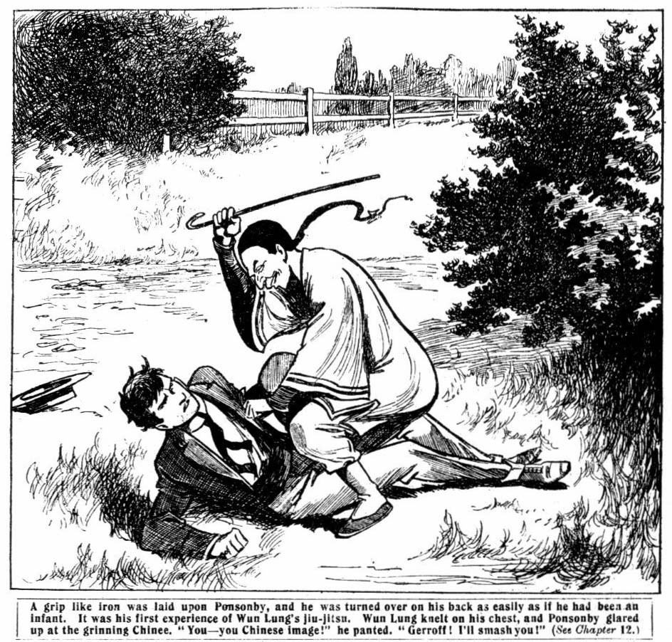
Wun Lung picked up Ponsonby’s cane and swung it away over the trees. Then he proceeded with great deliberation to rag the Highciffe fellow. Ponsonby was pinned down, and he could only struggle in vain. Wun Lung jerked his collar and tie off, and rumpled his hair, and rolled him over in the
dust and pommelled him in the ribs, and thudded his head on the ground. Ponsonby wriggled and roared. Then suddenly the Chinee desisted, and, springing up, took to his heels.
Ponsonby staggered to his feet.
He was feeling dazed and dizzy, he was rumpled all over, and smothered with dust. Wun Lung was vanishing in the
distance at a speed which rendered pursuit hopeless. The Highcliffe fellow, grinding his teeth, proceeded to put himself to rights again and hunted for his cane in the trees.
It was a quarter of an hour before he took his way again to
Highcliffe, in a decidedly vicious temper.
Wun Lung dropped into a walk when he was at a safe distance. He was chuckling gleefully. His right hand was closed, grasping something. He opened it, and grinned over the slip of crisp paper it contained. It was a five—pound note!
“ Ponsonby gleat lascal and gleat fool!” murmured Wun Lung contentedly , as he trotted on towards Greyfriars.
“Makee Dickee stealee bankee notee—gleat lascal! Bankee-notee b’longee old Flankee. He takee backee. Wun Lung velly good boy!”
THE THIRTEENTH CHAPTER.
The Brothers.
NUGENT MINOR came in at the school gates, tramping heavily along, his head bowed, and his hands thrust deep into his pockets. His face was pale and lined. The foolish and reckles lad was thinking, and his thoughts were a torment. He had done it now; it was done, and past recall. He had settled his debt of honour—and he had parted with his honour for good and all! He had tried to make out to himself that Frank ought to have helped him; that he wouldn’t have done it if Frank hadn’t acted like a brute. And at first, his reasoning had satisfied him. But the reaction had come. Strive as he might to drive it from his mind the thought would not be driven—the thought that he had made himself a thief; that he was not fit to look any decent fellow in the face again.
He did not fear exposure and punishment much. In the back of his mind was a reliance on his brother—his brother, whose interference he so keenly resented. Somehow or other Frank would save him. He did not know how; but he knew that Frank would save him from being known as a thief.
But there was something that even Frank could not save him from. No one could save him from his conscience, from the gnawing misery that had now mastered him, now that his excitement had died out from the grinding consciousness that he was no longer honest, that he had a miserable secret to keep, that he had no right to mingle again with the fellows on equal terms.
From that Frank could not save him.
“It was his fault—his fault!” the fag muttered again and again passionatly. “It was his fault!”
“Hallo! So you’ve got in!” growled Gatty, meeting him
in the Close.
Nugent minor did not reply. He walked on without heeding Gatty’s remark. He went into the School House and found his major waiting for him.
Frank came towards him, and the fag shrank back. But there was no anger in his brother’s look.
“I want to speak to you, Dick.” said Nugent very quietly.
“You—you mean—you——”
“Yes, I know.”
“It was your fault!”
“Never mind that.” said Frank still very quietly. “Come into the Form-room.”
Dick followed him silently into the Form-room. They had the room to themselves, and Frank closcd the door and turned to his brother.
Dick waited in miserable apprehension. The look on his brother’s face went to his very heart. He had been prepared for anger, fierce condemnation—violence even. He was ready for that—he was ready for a licking!” He could have opposed violence with sullenness; every blow would have fortified him, as it were, and made him more satisfied with himself, by incensing him more against Frank.
But there was evidently to be no violence. Frank was past that. His face was white—white with utter misery and shame. The blow that had fallen on him seemed to have crushed him. Dick had never seen his brother look like that before, and it brought a pain of wretched remorse to his heart. He would have given worlds at that moment to undo what he had done.
“I missed the banknote.” said Frank, his voice subdued and tremulous. “I knew where it had gone. You took it, Dick!”
“Yes.” said Dick. He tried to make his tone defiant, but the defiance was all gone out of him now.
“You stole it, Dick!”
“I—I took it! I—I borrowed it! I’m going to pay it back.” said Dick.
“Where will you get the money?”
Dick was silent. He knew that he could not get the money unless—unless he could win it from Ponsonby & Co. And he knew well enough that that would not happen.
“You stole it!” said Frank. “I missed it. And Bob Cherry was there. Wharton and Bull came in. They know it’s gone!”
Dick’s lip quivered.
“I knew you’d miss it soon.” he said. “I—I thought you’d have sense enough to keep it dark. Have you told all the fellows?”
“Only those three know, and they’ve agreed to keep it dark.”
Dick breathed again.
“Then there won’t be a row about it?”
“No.”
“But—but couldn’t you say something? You—you needn’t have told them that I took it.” muttered Dick. “They— they’ll think I’m a thief.”
“I don’t see what else they could think, Dick, if they knew you had taken it.”
“Then they don’t know?” exclaimed Dick.
“ No.”
“But—but they’ll think somebody’s taken it if they know it’s gone!” exclaimed Dick. “They’ll be hunting for the thief—for—for—the fellow who took it, I mean. It can’t be kept dark, Frank, if they think a thief has taken it.”
Frank smiled bitterly.
“You needn’t be afraid, Dick. They don’t think a thief has taken it. I haven’t told them any lies—I couldn’t; but I’ve let them suppose a lie, which is just as bad. They think I’ve had it.”
“You:”
“They think I’m five pounds short in the club accounts— and so I am. I’m going to make up the money myself, somehow. But—but you see what you’ve done to me, Dick.”
Dick had a scared look.
“Frank! You—you haven’t let them suppose that—that you embezzled the accounts!”
“I had to let them suppose so, or else tell them that my brother had gone to my desk and stolen the money.”
“Frank!”
“You know what it means to me, Dick. I’ve lost my friends.” Nugent’s voice broke for a moment, but he recovered himself and went on steadily. “ It will be kept dark. There will be no disgrace. I can trust them. But they will never speak to me again. They won’t chum with a swindler, and that’s what they think me now.”
“Frank”—it was a groan from the remorseful fag. “Frank! You—you’ve done that for me!”
“What else could I do? If it came out, you’d be sacked from the School, and how would the mater take that? There was only one way to cover up what you’ve done, and I’ve taken that way. I—I suppose I was partly to blame. I — I lost my temper with you the other night; I oughtn’t to have licked you.”
“That—that was what finished it.” muttered Dick.
“It can’t be helped now, Dick. But this has got to be the end of it. You’ve ruined me here. I’ve lost my pal through you. I’m going to change out of my study. Wharton will never speak to me again. If he did, I shouldn’t. If I can’t have his friendship, I won’t have his pity. I—I think I shall try to get pater to take me away from Grcyfriars.”
“Frank!”
“I don’t feel that I can stop here after this. But you owe me something, at least, Dick, after what you’ve done. I want you to make me a promise.”
“This can’t go on!” said Dick miserably. “I didt it—you didn’t! I can’t have you taking it on your shoulders like this !”
Nugent made a gesture.
“I’m glad you’re sorry for it, Dick. I know you didn’t mean to be a thief, either; but the other fellows wouldn’t understand that if they knew. It’s all right now—for you.”
“But for you, Frank?”
“Never mind me. I can stand it, especially as I shall get away from Greyfriars as soon as I can. But you must make me a promise, Dick. You owe me that.”
“I—I’ll do anything!” groaned Dick. “ I—I never foresaw this! I never thought anything of the kind!”
“I know you didn’t. But you can see now what Ponsonby and his set will lead you into. I want you to promise me never to gamble again, Dick, and to have nothing to do with the Highcliffe fellows. I think you owe me that much, after finishing me here.’’
“I’ll promise anything you like, Frank. I—I’ve been a fool—a fool—a beast!” gasped Dick. “I—I couldn’t see it before, and—and I never knew you would stand by me like this!”
“You give me your word, Dick?”
“Honour bright.”
Nugent drew a deep breath.
“That’s good enough, Dick. I know you won’t break your word. I’ll write home to the pater to-night about leaving. Goodness knows how I shall be able to explain to him; but I must do it somehow. I can’t stay here, with my old pals looking on me as a thief. I’ve got to get out. But it won’t be so bad if I feel sure that you’ll go straight after I’m gone.”
Dick Nugent sank upon a form and covered his face with his hands. The miserable fag burst into bitter sobbing.
He had felt, somehow, that Frank would save him from the consequences of his mad act. It was an instinctive feeling, and had not softened his heart towards his brother. But now he knew at what a terrible cost his brother had saved him. The wretched boy’s very heart was torn with remorse and horror.
The brother he had insulted and defied, whose interference he had bitterly resented —he had done this! He had sacrificed his own good name. He had thrown over the chums who trusted him, he had given up everything he held dear, and all for the wretched boy who hd reviled and repulspd him.
It was too much! The anguish he felt at that moment was a full punishment for all that the wretched fag had done.
“Don’t, Dick!” muttered Nugent. “Dont, old chap! It can’t be helped now! I tell you it can’t be helped! And you’re safe—quite safe!”
The fag only sobbed.
“Dick, I tell you it’s all right!”
“It isn’t all right!” Bick sprang to his feet, his eyes gleaming with resolution, a resolution which showed that, in spite of all his recklessness and folly, the boy was sound at the core. “ Frank, I can’t stand it! I won’t have it :
I can’t be such a beast!” I won’t be : I don’t care what happens. I’m going to tell them!”
“Dick—”
“I won’t stand it. Frank I—I should feel like a worm! I can’t stand it! I’m going to tell them!”
He ran to the door.
Dick! Stop! It won’t do any good now! Dick, I tell you—”
Frank Nugent sprang after him; but Dick had torn the door open, and he was gone. The clatter of his hurried footsteps died away down the passage.
Nugent stood irresolute.
He had made that fearful sacrifice to save Bicky——made it with a heavy heart, yet without repining. But it brought a throb of joy to his heart to know that Dick, after all, was not as callously selfish as to profit by his devotion and leave him to suffer; that the boy, after all, was honest and true at hekrt. With a strange mingling of feelings in his breast, Frank Nugent followed his minor to study No. 1.
THE FOURTEENTH CHAPTER.
Light at last!
WUN LUNG tapped at the door of Study No. 1 and
opened it.
Harry Wharton and Bob Cherry and Johnny Bull were in the study. They looked at the little Chinee with grin faces. Visitors were not welcome at that moment. There had been a dreary discussion in the study. The discovery of what Frank had done—or, rather, what he allowed them to suppose he had done—had come as a stunning blow to the chums of the Remove.
Such an accusation against Frank Nugent from any other lips they would have laughed to scorn.
But he was self-condemned!
There was therefore no room for doubt. Nugent had taken for his own use the money placed in his charge as treasurer, and the cards furnished only too plausible an explanation of what he had done with it.
It was a crushing blow for the Co. They had talked it over— miserably and drearily. There was no question but that it must be kept secret. The whole school should not be allowed to point the finger of scorn at their chum. But he could be their chum no longer. Friendhip could not stand that strain. They realised it with heavy hearts, and it was evident that Nugent realised it, too. A fellow who admitted that he had embezzled the money placed in his charge—that he was a thief, for that was the long and the short of it—— such a fellow had no claim upon the friendship of any decent lad. The Co. was broken up at last with a vengeance!
“Flankee here?” said Wun Lung.
“Wharton made an irritable gesture.
“No, buzz off now, kid! Don’t bother!”
Wun Lung’s eyes searched the dark and troubled faces in this study. He wondered if the juniors knew what he knew.
“Me wantee see Flankee,” he said.
“Well, he’s not here.’’
“Me wantee speakee Flankee velly much. You chapee no qualel with Flankee!” said Wun Lung inquiringly. Flankee velly good boy!”
“Oh, buzc off!” growled Johnny Bull.
“But me wantee—”
Wun Lung was interrupted. There was a hurried footstep in the passage, and Dick Nugent ran in, flushed, breathless, excited. In his excitement he did not even notice the presence of Wun Lung.
“Wharton ”—he panted out his words— “I’ve got something to tell you! It wasn’t Frank! Do you understand? It wasn’t—it wasn’t!”
Wharton started.
“What do you mean, Dick?”
“It wasn’t Frank! I did it!”
“You did what?”
“I took the money!”
“What?”
Wharton and Bob and Johnny Bull shouted it out together, They sprang to their feet in wild excitement. Bob grasped the fag by the shoulder.
“You, Dick! What do you mean? Get it out! Sharp!”
Dick panted.
Frank let you think that! But it wasn’t Frank. It was I! I—I owed Ponsonby money. I’d been gambling with him, and and I wanted to pay him. So I took it!”
“My hat!”
“You precious young rascal!” roared Johnny Bull furiously. “You came here and stole the Banknote, and let us think—”
“Frank’s only just told me.” panted Dicky. “ and—and I wouldn’t have it. He did it to save me. I—I’ve been a beast to him. But I couldn’t stand this, so I came to you. And now,” he faltered “now you can go and tell the head, if you like.”
“You!” gasped Wharton. “Oh, I understand now!” Back to his mind came the remembrance of Dick Nugent fumbling in Frank’s desk. He remembered now, and he wondered that he had not guessed the truth. But he had had no clue. Frank had deceived them—or rather, he had allowed them to deceive themselves to save his minor. Wharton understood at last. His face lighted up his heart was throbbing with relief.
“Oh, you fellows! What fools we’ve been! To think for a moment that old Frank—”
“I wouldn’t have believed it if he hadn’t said it himself!” said Bob.
“And now I come to think of it, he didn’t exactly say it, either!” muttered Johnny Bull. “He only said he was short in the accounts, and left us to make fools of ourselves.”
“And what have you come and told us for, you young villain?” demanded Bob Cherry.
“I wouldn’t let Frank stand it, that’s all.” Dick turned to the doorway as his major came in. “You’re too late, Frank. I’ve told them!”
“Frank, you ass!”
“You fathead, to let us think for a moment—”
“Oh, you duffer!”
“I—I had to do it,” stammered Nugent; “and—and you know, keep it dark. You know what would happen to Dick— You’ll keep it a secret? He’s promised never to see those cads again.’
“And I mean it!” skid Dick. “ I’ve been a beast—a beast; but I’m not asking you to keep it dark. I had to tell you it wasn’t Frank. You can do as asked you like.”
“It’s got to be kept dark.” said Nugent, in utter distress.
“For my sake, you fellows— Wun Lung, what are you doing here? Now it’s all out!” groaned Nugent, sinking into a chair.
“Me keepee seclet!” exclaimed Wun Lung hurriedly. ‘‘Me no talkee. Me knowee all timee.”
“You knew?”
“ Me see Dickee come here. Me knowee all timee.”
Wun Lung nodded.
“Me knowee. Alle light. Me no talkee. Me see Dickee
comee here. Me knowee.”
“Oh!”
“Bankee-notee no losee,” went on Wun Lung. “Me findee.”
“What?”
“You’ve found the banknote!” exclaimed Dick. “Rot!”
I gave it to Ponsonby. I wish I hadn’t now, but I did.”
“Dickee dreamee,” said Wun Lung coolly. Ponsonby no have bankee-notee. Me findee.”
“It’s impossible! I tell you, I paid Ponsonby with it— my— my debt of honour.”
“Debt of honour!” snorted Johnny Bull. “Debt of dishonour, you mean! You silly young fool, Ponsonby had no right to the money! And I’ll bet he cheated you. I know he cheats at cards. Smithy says so, and Smithy used to play with him.”
“But—but I met him in the old barn, and paid him!” stuttered the fag. “I tell you I did. If Wun Lung’s found a banknote, ‘tain’t that one.”
“Let’s see it, Wun Lung.”
The little Chinee handed the banknote to Nugent. Nugent examined it.
“That’s the number, right enough,” he said. “That’s my banknote.”
“Great Scott!”
“Dickee takee for little jokeee,” suggested Wun Lung amiably. “No tinkee Dickee tiefee. Little jokee. Me findee bankee note, blingee backee to old Flankee . All lightee?”
“Ponsonby must have dropped it!” said Dick, in amazement; “and he’ll miss it, and—”
“Ponsonby would have had to give up that note, anyway!” said Johnny Bull grimly. “He must have known that Dick couldn’t raise five pounds. I suppose he didn’t care where the money came from. But we’d have made him give up that note. The receiver is as bad is the thief. Wun Lung saved us from going over to Highcliffe, and extracting that note from Ponsonby. I don’t know what you fellows think, but I’d have called in the police rather than have let Ponsonby keep it.’’
Dick Nugent winced.
“I—I won some money from Ponsonby once.” he faltered.
“The first time I played with him I won a quid! After that he won it back, and and all my money, and an I O U for five—”
“Then he’s had all he’s entitled to!” said Wharton. “You young ass, can’t you see he let you win at first, to lead you on? Wun Lung, you are a brick! Now we’ve got the money back, this can be kept dark. But I tell you plainly, Dick Nugent, that if you have anything more to do with the Highcliffe chaps, it won’t kept dark long; you’ve given Frank quite enough trouble. You’ve got to keep straight, or it’s the sack, and that’s the long and short of it.”
Dick’s 1ips trembled.
“I promised Frank.” he said, in a low voice. “ Frank knows that I’ll keep my word.”
“I know it, Dick.”
“I—I’ve had more than enough of it.” faltered Dick. “I see now, I was playing the giddy goat! I’ve been a beast to Frank, and I’m sorry, and—and I’ll try to show that I mean it!”
“Good enough.” said Wharton. “ ‘Nuff said, you fellows; all this has got to be forgotten. But if you ever play the giddy goat again, old man, we’ll give you a study licking. Jolly good mind to give you one now. You can think of us next time, and not so much of your dashed minor!”
Frank grinned.
“There won’t be any next time!” he said.
* * * * *
And there never was a “next time”. Dick Nugent had
had his lesson, and if afterwards he felt tempted to stray from the straight path, the remembrance of that “debt of dishonour” was sufficient to keep him steady. Ponsonby was probably surprised when he missed the banknote: but, considering the circumstances under which he had obtained possession of it, it was not possible for him to seek to regain it. He knew very well, when he considered the matter, that if Dickie had borrowed it, it must have been without the knowledge of its owner, and that to the receiver was as bad as the thief.
That would not have prevented the unscrupulous young rascal from keeping it, but it prevented him from inquiring after it. He was surprised, too, at not hearing again from his young friend at Greyfriars; and still more surprised when he wrote to Dicky, and his letter was returned unopened. Dicky had evidently found out what his friendship was worth, and wanted no more of it. And Ponsonby ground his teeth, and swallowed his chagrin as best he could. From that day there was complete confidence between Nugent and his minor, and Dicky was in no danger of contracting another debt of dishonour.


